Contents

[Networking Product and Services Catalogue 3](#_Toc55057374)

[Secure network infrastructure 3](#_Toc55057375)

[On-prem and branch connectivity 4](#_Toc55057376)

[Remote work connectivity 4](#_Toc55057377)

[5G and edge computing 5](#_Toc55057378)

[Secure global app delivery 5](#_Toc55057379)

[Vnet 5](#_Toc55057380)

[VNet concepts 6](#_Toc55057381)

[VNet Components: 6](#_Toc55057382)

[VNet Security tab options: 6](#_Toc55057383)

[Address Space 6](#_Toc55057384)

[Subnet 7](#_Toc55057385)

[NIC (network interface card) 7](#_Toc55057386)

[Filter network traffic 8](#_Toc55057387)

[Azure Firewall (firewall-as-a-service) 8](#_Toc55057388)

[Network Security Group (Layer 4 stateful Firewall) 9](#_Toc55057389)

[Application Security Group 9](#_Toc55057390)

[Application Security Group vs Network Security Group 10](#_Toc55057391)

[NAT or Destination Network Address Translation (DNAT) 10](#_Toc55057392)

[Network virtual appliances (Third Party) 11](#_Toc55057393)

[Communicate between Azure resources 12](#_Toc55057394)

[Communicate with on-premises resources 12](#_Toc55057395)

[Route network traffic 13](#_Toc55057396)

[System route 13](#_Toc55057397)

[Custom routes 14](#_Toc55057398)

[Bordergatewayprotocol (BGP) routes**:** 15](#_Toc55057399)

[Virtual network integration for Azure services 15](#_Toc55057400)

[Virtual network service endpoints 16](#_Toc55057401)

[Azure Private Endpoint 18](#_Toc55057402)

[Azure Private Links vs Service Endpoints 19](#_Toc55057403)

[Deploy dedicated Azure services into virtual networks 20](#_Toc55057404)

[Azure DNS (Route 53 ) 20](#_Toc55057405)

[Private DNS 21](#_Toc55057406)

[VNET Peering 22](#_Toc55057407)

[Global Peering 22](#_Toc55057408)

[Allow Forwarded Traffic 22](#_Toc55057409)

[Gateway Transit 22](#_Toc55057410)

[Use Remote Gateway 23](#_Toc55057411)

[VNet Peering vs VPN Gateway 23](#_Toc55057412)

[Virtual Network Gateway 25](#_Toc55057413)

[Gateway types 25](#_Toc55057414)

[VPN 26](#_Toc55057415)

[Gateway subnet 26](#_Toc55057416)

[VPN Types based on Connectivity: 27](#_Toc55057417)

[Point to Site(P2S): 27](#_Toc55057418)

[Site to Site (S2S): 28](#_Toc55057419)

[VNet-to-VNet (VNet2VNet) 30](#_Toc55057420)

[Virtual Network Gateway SKUs by feature set 31](#_Toc55057421)

[VPN types based on network routing 32](#_Toc55057422)

[PolicyBased: 32](#_Toc55057423)

[RouteBased: 32](#_Toc55057424)

[Express Route 33](#_Toc55057425)

[Key benefits 33](#_Toc55057426)

[Gateway subnet 34](#_Toc55057427)

[Express Route Direct 34](#_Toc55057428)

[Express Route FastPath 35](#_Toc55057429)

[Express Route Global Reach 35](#_Toc55057430)

[Azure Relay 36](#_Toc55057431)

[Hybrid Connections 37](#_Toc55057432)

[Azure App Service Hybrid Connections 37](#_Toc55057433)

[Data gateway 38](#_Toc55057434)

[Virtual WAN 38](#_Toc55057435)

[Network Security Monitoring 40](#_Toc55057436)

[Azure Security Center 40](#_Toc55057437)

[Azure Sentinel 40](#_Toc55057438)

[Azure Network Watcher 40](#_Toc55057439)

[Traffic Analytics 41](#_Toc55057440)

[FAQs 41](#_Toc55057441)

[Virtual Network basics 41](#_Toc55057442)

[Name Resolution (DNS) 42](#_Toc55057443)

[Connecting virtual machines 43](#_Toc55057444)

[Azure services that connect to VNets 44](#_Toc55057445)

[VNet peering 44](#_Toc55057446)

[Load Balancers 46](#_Toc55057447)

[Application Delivery 46](#_Toc55057448)

[Decision tree for load balancing in Azure 46](#_Toc55057449)

[Azure Load Balancer 47](#_Toc55057450)

[Backend Pools 49](#_Toc55057451)

[Health Probe 49](#_Toc55057452)

[Session Persistence 49](#_Toc55057453)

[Load Balancer SKUs 51](#_Toc55057454)

[Azure Load Balancer vs Azure Application Gateway vs Azure Traffic Monitor 52](#_Toc55057455)

[Azure Application Gateway 52](#_Toc55057456)

[Application Gateway Features 53](#_Toc55057457)

[Application Gateway Infrastructure 53](#_Toc55057458)

[Routing / listeners 55](#_Toc55057459)

[Web Application Firewall (WAF) 57](#_Toc55057460)

[SLA 58](#_Toc55057461)

[Traffic Manager 58](#_Toc55057462)

[Routing methods 59](#_Toc55057463)

[Azure Front Door 61](#_Toc55057464)

[URL-based routing 62](#_Toc55057465)

[Multiple-site hosting 62](#_Toc55057466)

[TLS termination 62](#_Toc55057467)

[Application layer security 62](#_Toc55057468)

# Networking Product and Services Catalogue

<https://azure.microsoft.com/en-in/product-categories/networking/>

<https://docs.microsoft.com/en-us/azure/networking/networking-overview>

## Secure network infrastructure

Build and protect your virtual network infrastructure.

| **If you want to** | **Use this** |
| --- | --- |
| Connect everything from virtual machines to incoming VPN connections | [Azure Virtual Network](https://azure.microsoft.com/en-in/services/virtual-network/) |
| Balance inbound and outbound connections and requests to applications | [Azure Load Balancer](https://azure.microsoft.com/en-in/services/load-balancer/) |
| Protect your applications from DDoS attacks | [Azure DDoS Protection](https://azure.microsoft.com/en-in/services/ddos-protection/) |
| Native firewall capabilities with built-in high availability and zero maintenance | [Azure Firewall](https://azure.microsoft.com/en-in/services/azure-firewall/) |
| Manage network security policy and routing centrally | [Azure Firewall Manager](https://azure.microsoft.com/en-in/services/firewall-manager/) |
| Private and fully managed RDP and SSH access to your virtual machines | [Azure Bastion](https://azure.microsoft.com/en-in/services/azure-bastion/) |
| Private access to services hosted on the Azure platform | [Azure Private Link](https://azure.microsoft.com/en-in/services/private-link/) |
| Route incoming traffic for better performance and availability | [Traffic Manager](https://azure.microsoft.com/en-in/services/traffic-manager/) |
| Monitor and diagnose network issues | [Network Watcher](https://azure.microsoft.com/en-in/services/network-watcher/) |

## On-prem and branch connectivity

Connect your on-premises datacenter and branches to the cloud.

| **If you want to** | **Use this** |
| --- | --- |
| Add private network connectivity from your corporate network to cloud | [Azure ExpressRoute](https://azure.microsoft.com/en-in/services/expressroute/) |
| Connect business offices, retail locations and sites securely with a unified portal | [Azure Virtual WAN](https://azure.microsoft.com/en-in/services/virtual-wan/) |
| Securely use the internet to access Azure Virtual Networks | [Azure VPN Gateway](https://azure.microsoft.com/en-in/services/vpn-gateway/) |

## Remote work connectivity

Enable remote users to access internal resources

| **If you want to** | **Use this** |
| --- | --- |
| Securely use the internet to access Azure Virtual Networks | [Azure VPN Gateway](https://azure.microsoft.com/en-in/services/vpn-gateway/) |
| Connect business offices, retail locations and sites securely with a unified portal | [Azure Virtual WAN](https://azure.microsoft.com/en-in/services/virtual-wan/) |
| Protect your applications from DDoS attacks | [Azure DDoS Protection](https://azure.microsoft.com/en-in/services/ddos-protection/) |

## 5G and edge computing

Enable edge computing platforms and apps on 5G enabled devices.

| **If you want to** | **Use this** |
| --- | --- |
| Provide real-time customer experiences with ultra-low-latency edge compute | [Azure Edge Zones, Azure Edge Zones with carrier, Azure Private Edge Zones](https://azure.microsoft.com/en-in/solutions/low-latency-edge-computing/) |

## Secure global app delivery

Build, secure and deliver applications to serve a global user base.

| **If you want to** | **Use this** |
| --- | --- |
| Accelerate the delivery of high-bandwidth content to customers worldwide | [Azure CDN](https://azure.microsoft.com/en-in/services/cdn/) |
| Scalable, security-enhanced delivery point for global, microservice-based web applications | [Azure Front Door](https://azure.microsoft.com/en-in/services/frontdoor/) |
| Manage traffic to your web applications with a web traffic load balancer. | [Azure Application Gateway](https://azure.microsoft.com/en-in/services/application-gateway/) |
| Use a firewall service for web apps to help improve web app security | [Azure Web Application Firewall](https://azure.microsoft.com/en-in/services/web-application-firewall/) |
| Ensure ultra-fast DNS responses and availability for your domain needs. | [Azure DNS](https://azure.microsoft.com/en-in/services/dns/) |
| Private access to services hosted on the Azure platform | [Azure Private Link](https://azure.microsoft.com/en-in/services/private-link/) |
| Test how networking infrastructure changes will impact performance | [Internet Analyzer](https://azure.microsoft.com/en-in/services/internet-analyzer/) |

# Vnet

<https://docs.microsoft.com/en-us/azure/virtual-network/virtual-networks-overview>

<https://www.youtube.com/watch?v=7rzawA--r20>

## VNet concepts

* **Address space:** When creating a VNet, you must specify a custom private IP address space using public and private (RFC 1918) addresses.
* **Subnets:** Subnets enable you to segment the virtual network into one or more sub-networks and allocate a portion of the virtual network's address space to each subnet**. You can secure resources within subnets using Network Security Groups.** For more information, see [Network security groups](https://docs.microsoft.com/en-us/azure/virtual-network/security-overview).
* **Regions**: VNet is scoped to a single region/location; however, multiple virtual networks from different regions can be **connected together using Virtual Network Peering**.
* **Subscription**: VNet is scoped to a subscription. You can implement multiple virtual networks within each Azure subscription and Azure region.

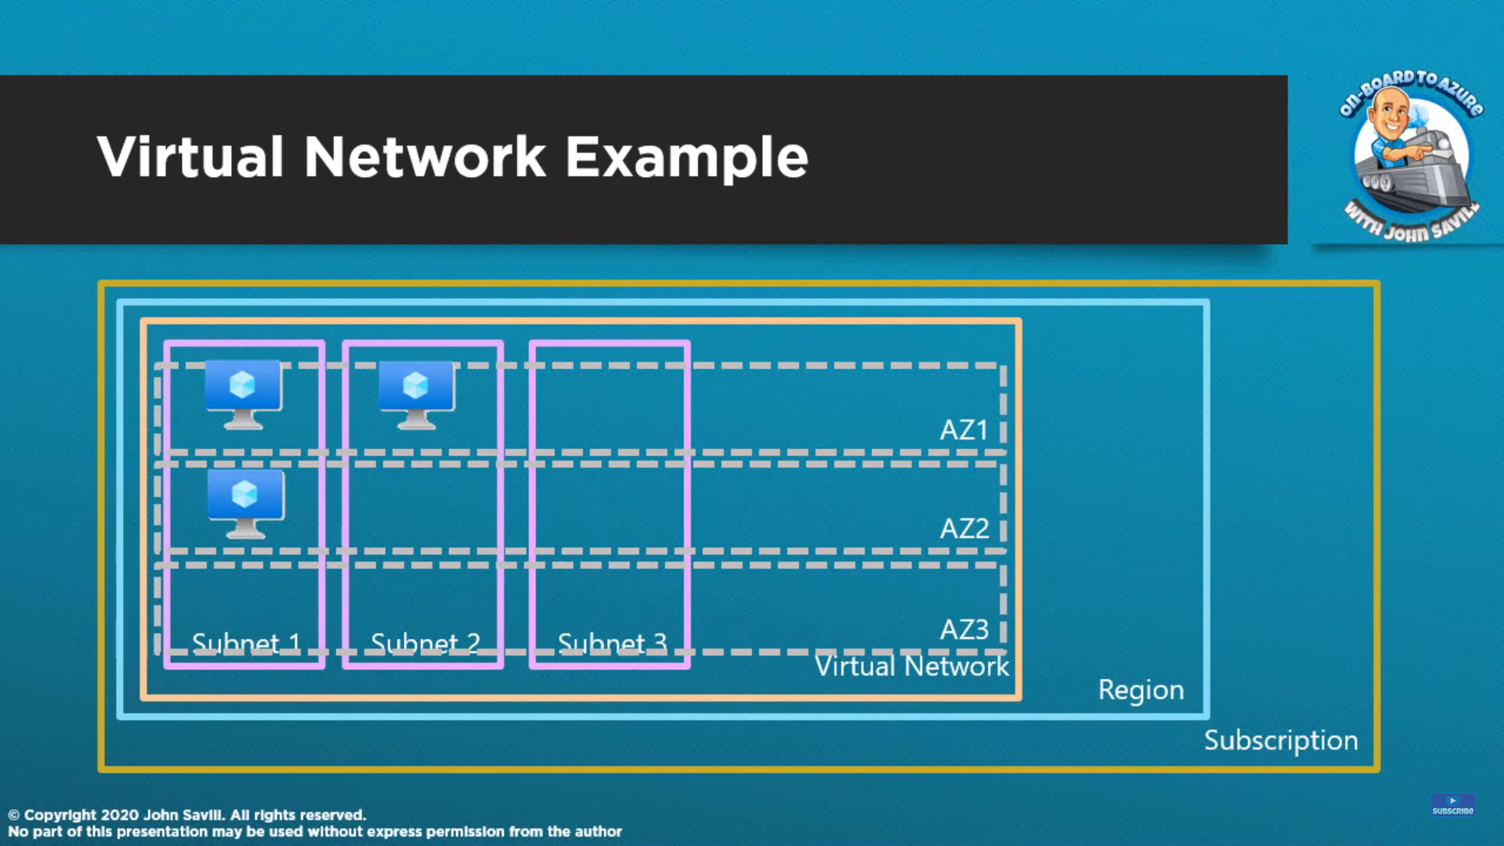

## VNet Components:

### VNet Security tab options:

**BastionHost**

**DDoS Protection Standard**

**Firewall**

### Address Space

A VNet can have multiple range of address space.

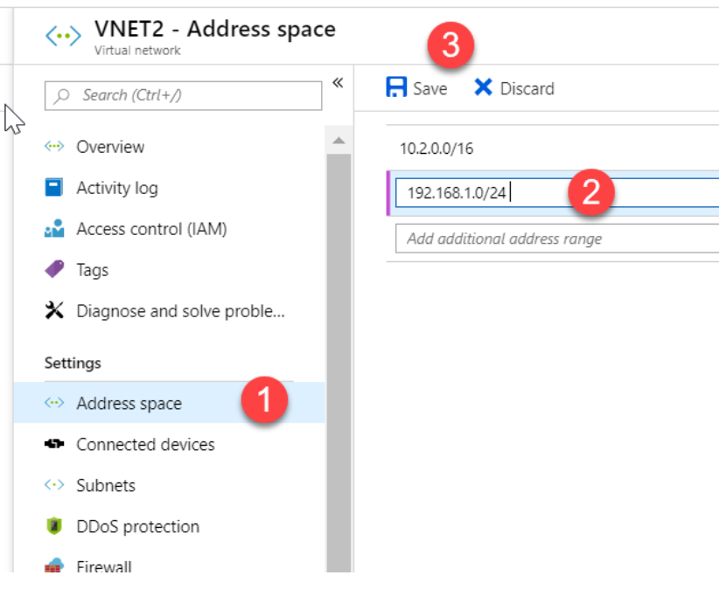

### Subnet

Service Endpoint is part of subnet

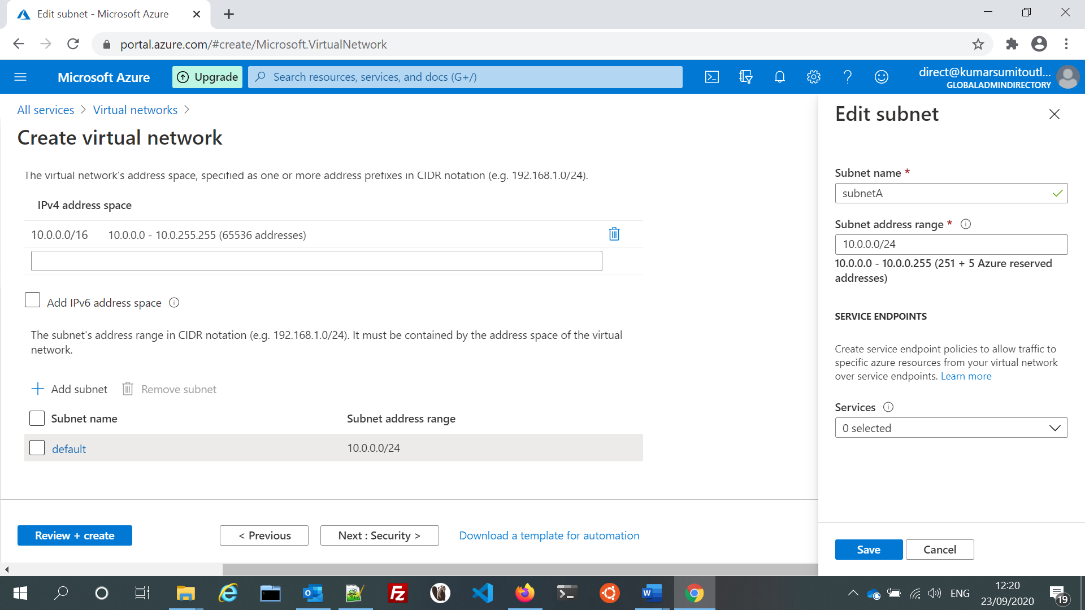

### NIC (network interface card)

<https://docs.microsoft.com/en-us/azure/virtual-network/virtual-network-multiple-ip-addresses-powershell>

**An Azure Virtual Machine (VM) has one or more network interfaces (NIC) attached to it. Any NIC can have one or more static or dynamic public and private IP addresses assigned to it.** Assigning multiple IP addresses to a VM enables the following capabilities:

* Hosting multiple websites or services with different IP addresses and SSL certificates on a single server.
* Serve as a network virtual appliance, such as a firewall or load balancer.
* The ability to add any of the private IP addresses for any of the NICs to an Azure Load Balancer back-end pool. In the past, only the primary IP address for the primary NIC could be added to a back-end pool.

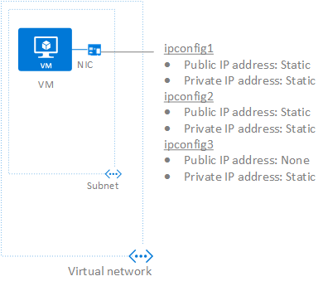

## Filter network traffic

Network level segmentation (design pattern)

<https://docs.microsoft.com/en-us/azure/architecture/reference-architectures/hybrid-networking/network-level-segmentation>

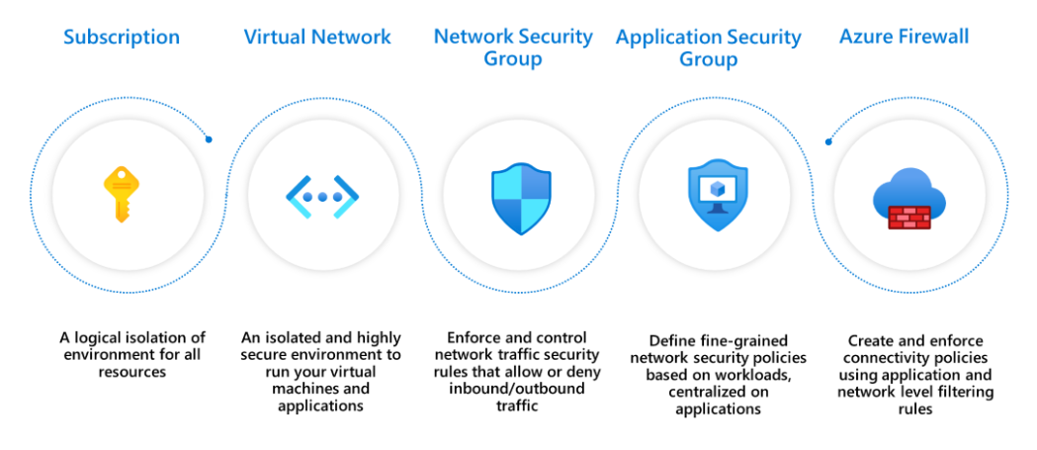

### Azure Firewall (firewall-as-a-service)

<https://docs.microsoft.com/en-us/azure/firewall/features> s

Azure firewall is a cloud native stateful firewall as a service.

Azure Firewall provides inbound protection for non-HTTP/S protocols (for example, RDP, SSH, FTP), outbound network-level protection for all ports and protocols, and application-level protection for outbound HTTP/S.

### Network Security Group (Layer 4 stateful Firewall)

<https://docs.microsoft.com/en-us/azure/virtual-network/network-security-groups-overview>

<https://petri.com/apply-nsg-policies-applications-azure>

Azure has a built-in, distributed Layer-4 stateful firewall system called Network Security Groups (NSGs). An NSG is a firewall policy, defining a collection of inbound and outbound allow or deny rules for network traffic. A collection of default rules are included and administrators typically add inbound rules to allow traffic into applications or services running on virtual machines, and optionally add outbound rules to control data leakage.

NSGs can be and are by default in the Azure Portal, assigned to the NICs of virtual machines on a 1:1 basis but that doesn’t really scale well. **Instead, we should create and assign NSGs at the subnet level.** The source and destinations in the firewall rules can be tags/locations such as Azure SQL, Virtual Network, or a network/specific address.

Auto-Scaling will dynamically add and reduce the number of web servers in your deployment based on a set of administrator-defined rules. Someone is going to have to add those IP addresses to the NSG rules. To mitigate manual addition of individual IPs one can opt for Application Security Group

#### NSG flow logs

<https://docs.microsoft.com/en-us/azure/network-watcher/network-watcher-nsg-flow-logging-overview>

[Network security group](https://docs.microsoft.com/en-us/azure/virtual-network/security-overview#security-rules) (NSG) flow logs is a feature of Azure Network Watcher that allows you to log information about IP traffic flowing through an NSG. Flow data is sent to Azure Storage accounts from where you can access it as well as export it to any visualization tool, SIEM, or IDS of your choice.

#### Azure Firewall and NSG Comparison

<https://darawtechie.com/2019/09/05/azure-firewall-vs-network-security-group-nsg/>

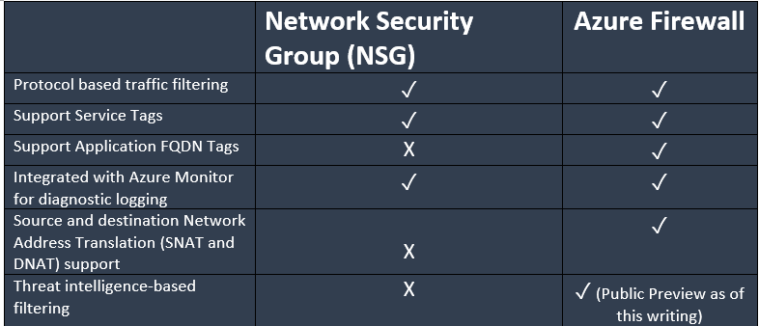

#### Azure Firewall and NSG in Conjuction

NSGs and Azure Firewall work very well together and are not mutually exclusive or redundant.  You typically want to use **NSGs when you are protecting network traffic in or out of a subnet**.  An example would be a subnet that contains VMs that require RDP access (TCP over 3389) from a Jumpbox. **Azure Firewall is the solution for filtering traffic to a VNet from the outside**.  For this reason, it should be deployed in it’s own VNet and isolated from other resources**.  Azure Firewall is a highly available solution that automatically scales based on its workload.**  Therefore, **it should be in a /26 size subnet** to ensure there’s space for additional VMs that are created when it’s scaled out.

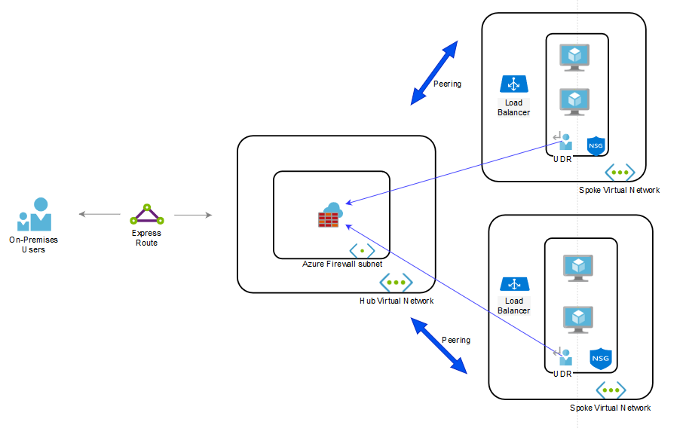

Another reference architecture

<https://docs.microsoft.com/en-us/azure/architecture/reference-architectures/dmz/secure-vnet-dmz>

### Application Security Group

<https://docs.microsoft.com/en-us/azure/virtual-network/application-security-groups>

<https://medium.com/awesome-azure/azure-application-security-group-asg-1e5e2e5321c3>

<https://petri.com/understanding-application-security-groups-in-the-azure-portal>

An **application security group** allows you to logically group a number of virtual machines NICs from the same virtual network and apply a network security group (NSG) rule to them.

You join virtual machines to the application security group, and then use the application security group as a source or destination in NSG rules

Note:

* All network interfaces in an Application Security Group must be connected to the same virtual network.
* If you specify Application Security Groups as the destination and source of an NSG rule, then the source and destination network interfaces must also be in the same virtual network.

### Application Security Group vs Network Security Group

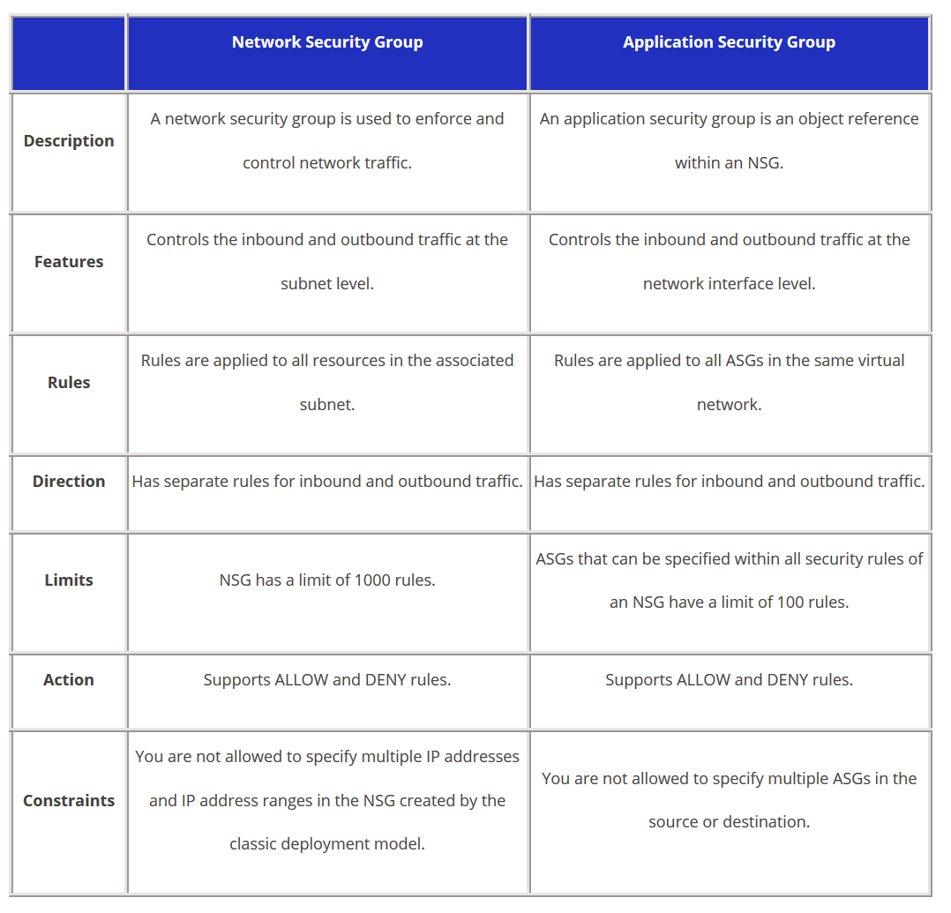

<https://tutorialsdojo.com/network-security-group-nsg-vs-application-security-group/>

### NAT or Destination Network Address Translation (DNAT)

<https://docs.microsoft.com/en-us/azure/virtual-network/nat-overview>

<https://www.youtube.com/watch?v=vIGEmrhiuXo>

<https://www.youtube.com/watch?v=G67TaU4qSYE>

The goal of NAT is to publish an otherwise private service, through a firewall, via an IP address. NAT should be part of a public subnet and it only provides outbound traffic and hence more secure. With the help of route tables private subnet traffic can be forwarded to NAT and doing so private subnet can access internet without having a public IP.

Virtual Network NAT (network address translation) simplifies **outbound-only Internet connectivity for virtual networks.** When configured on a subnet, all outbound connectivity uses your specified static public IP addresses. **Outbound connectivity is possible without load balancer or public IP addresses directly attached to virtual machines**. NAT is fully managed and highly resilient.

By Default, Azure provides **outbound** SNAT/PAT enabling resources to access the internet and receive responses.

<https://petri.com/understanding-and-creating-nat-rules-in-azure-firewall>

**Implicit Network Rules**

When traffic is coming into your firewall and a matching NAT rule is found, **an implicit network rule is created to allow the traffic.** If you wish, you can create Network Rules (in Network Rules Collections) to allow this traffic or to **create very granular deny rules**.

### **Network virtual appliances (Third Party)**

<https://azure.microsoft.com/en-in/solutions/network-appliances/>

A network virtual appliance is a VM that performs a network function, such as a firewall, WAN optimization, or other network function.

Normally when it is asked to route all the traffic of a VNet via one VM, that VM is acting as a virtual appliance.

|  |  |  |
| --- | --- | --- |
|  | Azure Firewall | Third Party NVA |
| Cost | Azure Firewall is about 30-50% less costly than NVA | VM+ Software |
| Business Need | Customer’s Call | Customer’s Call |
| Existing Skills and Trust | Must learn few new concepts for configuring Azure firewall | If you trust the brand and you have a large skill base |
| Licensing | Consumption: instance + per GB | VM + Software |
| Maintenance | Azure will take care | Customer responsibility |
| Ownership | Set & monitor | Manage VM / OS / Software |
| Support | Included in your Azure Support plan | Per NVA vendor billing model |
| Complexity | Simple | Difficult |

<https://azure.microsoft.com/en-us/blog/azure-firewall-and-network-virtual-appliances/>

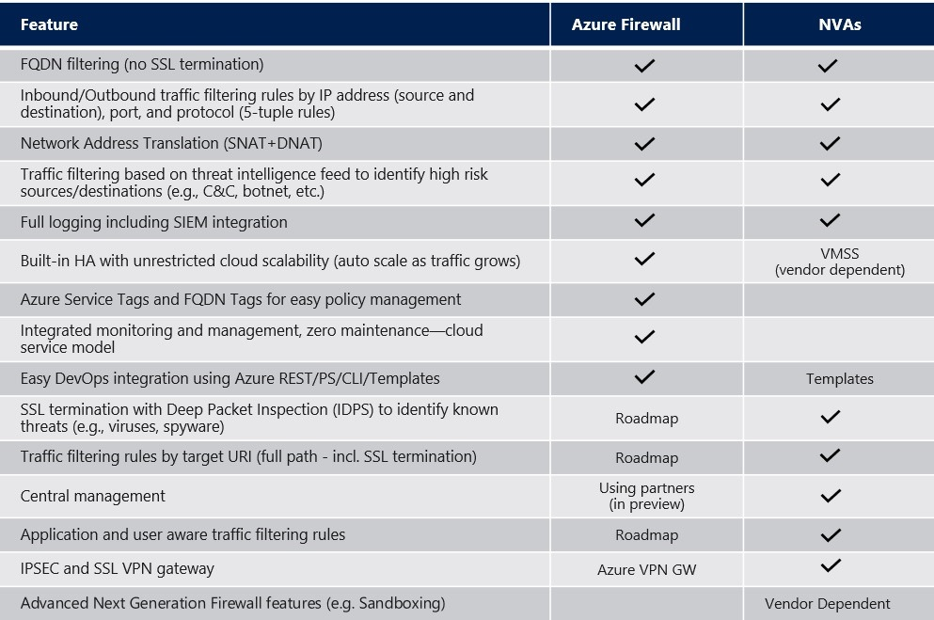

## Communicate between Azure resources

* **Through a virtual network**: You can deploy VMs, and several other types of Azure resources to a virtual network, such as Azure App Service Environments, the Azure Kubernetes Service (AKS), and Azure Virtual Machine Scale Sets.
* **Through a virtual network service endpoint**: Extend your virtual network private address space and the identity of your virtual network to Azure service resources, such as Azure Storage accounts and Azure SQL Database, over a direct connection. Service endpoints allow you to secure your critical Azure service resources to only a virtual network.
* **Through VNet Peering**: You can connect virtual networks to each other, enabling resources in either virtual network to communicate with each other, using virtual network peering. The virtual networks you connect can be in the same, or different, Azure regions.

## Communicate with on-premises resources

* **Point-to-site virtual private network (VPN):** Established between a virtual network and a single computer in your network.
* **Site-to-site VPN:** Established between your on-premises VPN device and an Azure VPN Gateway that is deployed in a virtual network.
* **Azure ExpressRoute:** Established between your network and Azure, through an ExpressRoute partner. This connection is private. Traffic does not go over the internet.

Communicate with internet

* Assign a public IP to service. Least preferred
* Place the instance/service behind Load Balancer which has a public IP in the front-end configuration
* Use a **network virtual appliance** with a public IP ( <https://azure.microsoft.com/en-in/solutions/network-appliances/> )

## Route network traffic

<https://docs.microsoft.com/en-us/azure/virtual-network/virtual-networks-udr-overview>

<https://www.youtube.com/watch?v=tXLScLO-DRI>

<https://www.youtube.com/watch?v=sBII38Fngmk>

Two types of route table exist in Azure

### System route

Azure automatically creates system routes and assigns the routes to each subnet in a virtual network. **You can't create system routes, nor can you remove system routes, but you can override some system routes** with [custom routes](https://docs.microsoft.com/en-us/azure/virtual-network/virtual-networks-udr-overview#custom-routes). Azure creates default system routes for each subnet, and adds additional [optional default routes](https://docs.microsoft.com/en-us/azure/virtual-network/virtual-networks-udr-overview#optional-default-routes) to specific subnets, or every subnet, when you use specific Azure capabilities.

The default “Sytstem route” has following entries:

|  |  |  |
| --- | --- | --- |
| Source | Address prefixes | Next hop type |
| Default | Unique to the virtual network | Virtual network |
| Default | 0.0.0.0/0 | Internet |
| Default | 10.0.0.0/8 | None |
| Default | 192.168.0.0/16 | None |
| Default | 100.64.0.0/10 | None |

Explanations for the next hop types follow:

* **Virtual network**: Routes traffic between address ranges within the [address space](https://docs.microsoft.com/en-us/azure/virtual-network/manage-virtual-network#add-or-remove-an-address-range) of a virtual network. If the virtual network address space has multiple address ranges defined, Azure creates an individual route for each address range. Azure automatically routes traffic between subnets using the routes created for each address range. You don't need to define gateways for Azure to route traffic between subnets. Though a virtual network contains subnets, and each subnet has a defined address range, Azure does not create default routes for subnet address ranges, because each subnet address range is within an address range of the address space of a virtual network.
* **Internet**: Routes traffic specified by the address prefix to the Internet. The system default route specifies the 0.0.0.0/0 address prefix. **You can override Azure's default system route for the 0.0.0.0/0 address prefix with a**[**custom route**](https://docs.microsoft.com/en-us/azure/virtual-network/virtual-networks-udr-overview#custom-routes)**.**
* **None**: Traffic routed to the **None** next hop type is dropped, rather than routed outside the subnet. Azure automatically creates default routes for the following address prefixes:
  + 10.0.0.0/8 and 192.168.0.0/16: Reserved for private use in RFC 1918.
  + 100.64.0.0/10: Reserved in RFC 6598.

Optional default routes next hop type depending on if those services/options were chosen:

* **Virtual network (VNet) peering**: When you create a virtual network peering between two virtual networks, a route is added for each address range within the address space of each virtual network a peering is created for.
* **Virtual network gateway**: One or more routes with Virtual network gateway listed as the next hop type are added when a virtual network gateway is added to a virtual network. The source is also virtual network gateway, because the gateway adds the routes to the subnet.
* **VirtualNetworkServiceEndpoint**: The public IP addresses for certain services are added to the route table by Azure when you enable a service endpoint to the service. Service endpoints are enabled for individual subnets within a virtual network, so the route is only added to the route table of a subnet a service endpoint is enabled for.

### Custom routes

You create custom routes by either creating [user-defined](https://docs.microsoft.com/en-us/azure/virtual-network/virtual-networks-udr-overview#user-defined) routes, or by exchanging [border gateway protocol](https://docs.microsoft.com/en-us/azure/virtual-network/virtual-networks-udr-overview#border-gateway-protocol) (BGP) routes between your on-premises network gateway and an Azure virtual network gateway.

* User defined Route table

Following next hop types are allowed in UDR :

* + **Virtual appliance**: A virtual appliance is a virtual machine that typically runs a network application, such as a firewall.
  + **Virtual network gateway**: Specify when you want traffic destined for specific address prefixes routed to a virtual network gateway**. The virtual network gateway must be created with type VPN**. **You cannot specify a virtual network gateway created as type ExpressRoute in a user-defined route because with ExpressRoute, you must use BGP for custom routes.**
  + **None**: Specify when you want to drop traffic to an address prefix, rather than forwarding the traffic to a destination.
  + **Virtual network**: Specify when you want to override the default routing within a virtual network.
  + **Internet**: Specify when you want to explicitly route traffic destined to an address prefix to the Internet, or if you want traffic destined for Azure services with public IP addresses kept within the Azure backbone network.

You cannot specify **VNet peering** or **VirtualNetworkServiceEndpoint** as the next hop type in **user-defined** routes.

### **Border gateway** protocol (BGP) routes**:**

An on-premises network gateway can exchange routes with an Azure virtual network gateway using the border gateway protocol (BGP). Using BGP with an Azure virtual network gateway is dependent on the type you selected when you created the gateway. If the type you selected were:

* **ExpressRoute**: **You must use BGP to advertise on-premises routes to the Microsoft Edge router.** You cannot create user-defined routes to force traffic to the ExpressRoute virtual network gateway if you deploy a virtual network gateway deployed as type: ExpressRoute. You can use user-defined routes for forcing traffic from the Express Route to, for example, a Network Virtual Appliance.
* **VPN**: **You can, optionally use BGP**. For details, see [BGP with site-to-site VPN connections](https://docs.microsoft.com/en-us/azure/vpn-gateway/vpn-gateway-bgp-overview?toc=/azure/virtual-network/toc.json).

**Route propagation should not be disabled on the GatewaySubnet. The gateway will not function with this setting disabled.**

ER and VPN Gateway route propagation can be disabled on a subnet using a property on a route table. When you exchange routes with Azure using BGP, routes are not added to the route table of all subnets with Virtual network gateway route propagation disabled.

Note :

1. Route table should be associated with subnet for making it functional else it will not be used.
2. If multiple routes contain the same address prefix, Azure selects the route type, based on the following priority:
   1. User-defined route
   2. BGP route
   3. System route
3. Step by step guide on route table : <https://campus.barracuda.com/product/cloudgenfirewall/doc/72516173/how-to-configure-azure-route-tables-udr-using-azure-portal-and-arm/>
4. BGP will be used in both the scenarios:

Your company has two on-premises sites in New York and Los Angeles and Azure virtual networks in the East US Azure region and the West US Azure region.  
Each on-premises site has Azure ExpressRoute circuits to both regions.  
You need to recommend a solution that meets the following requirements:  
✑ Outbound traffic to the Internet from workloads hosted on the virtual networks must be routed through the closest available on-premises site.  
✑ If an on-premises site fails, traffic from the workloads on the virtual networks to the Internet must reroute automatically to the other site.

## Virtual network integration for Azure services

### Virtual network service endpoints

<https://docs.microsoft.com/en-us/azure/virtual-network/virtual-network-service-endpoints-overview>

<https://www.youtube.com/watch?v=gxsitRRgylI>

Virtual Network (VNet) service endpoint provides secure and direct connectivity to Azure services over an optimized route over the Azure backbone network. Endpoints allow you to secure your critical Azure service resources to only your virtual networks.

**Service Endpoints enables private IP addresses in the VNet to reach the endpoint of an Azure service without needing a public IP address on the VNet.**

Virtual network service endpoint policies

<https://docs.microsoft.com/en-us/azure/virtual-network/virtual-network-service-endpoint-policies-overview>

Virtual Network (VNet) service endpoint policies allow you to filter egress virtual network traffic to Azure Storage accounts over service endpoint and allow data exfiltration to only specific Azure Storage accounts.

Using this policy you can restrict access to service endpoint by setting scope at:

* Single account
* All accounts in subscription
* All accounts in resource group

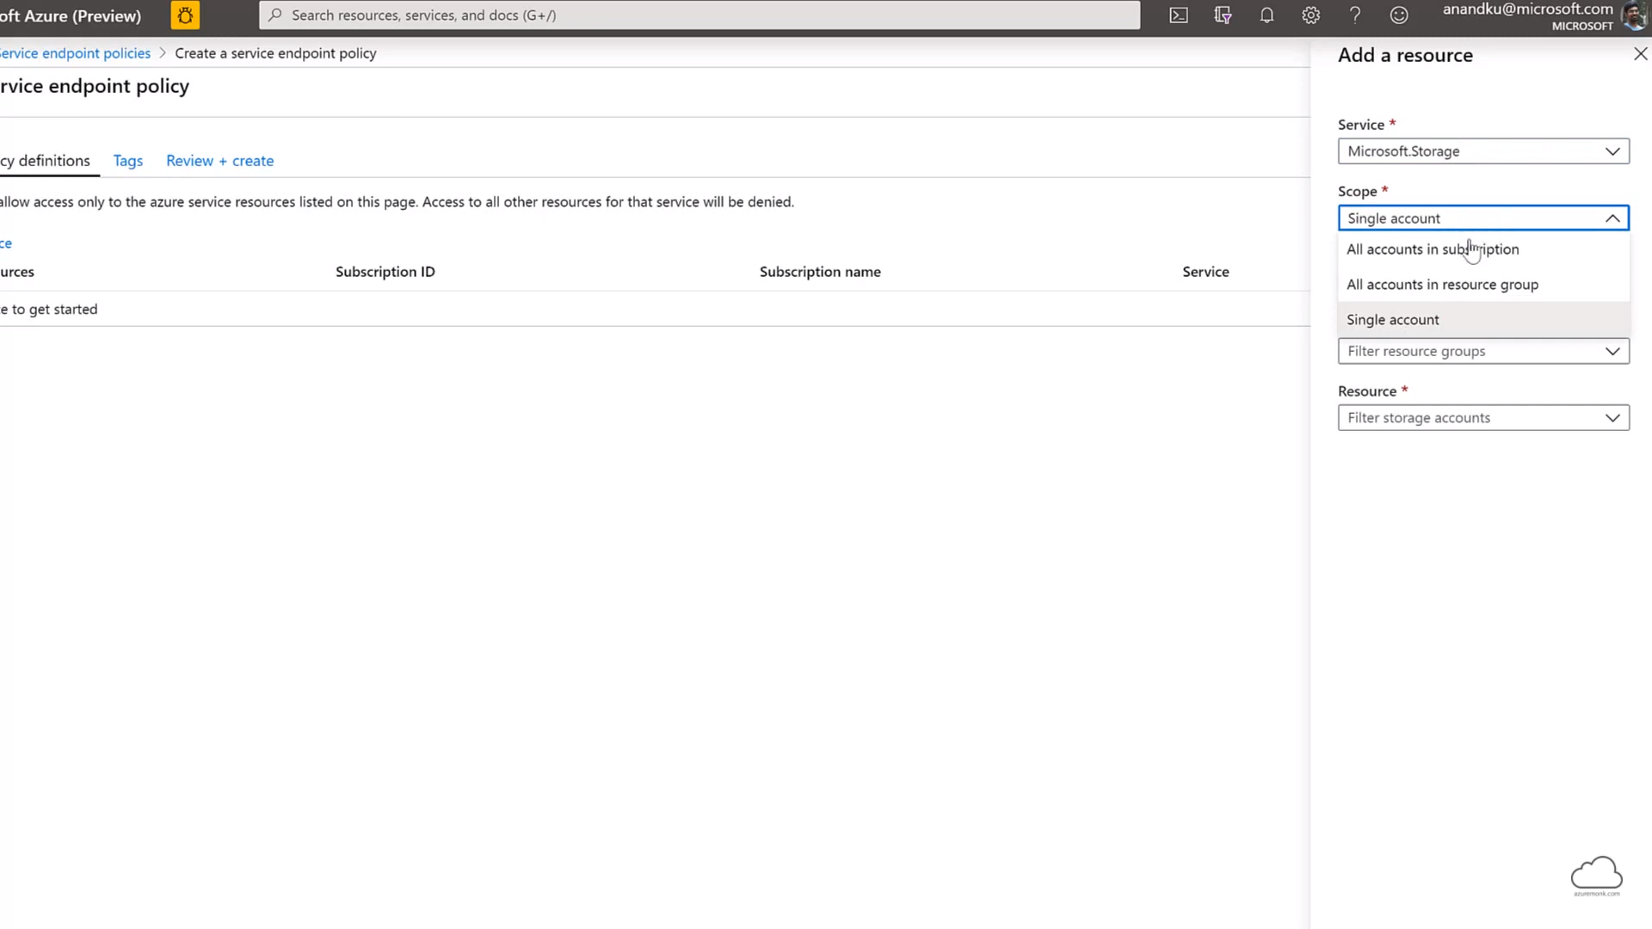

Secure Azure service access from on-premises

By default, Azure service resources secured to virtual networks aren't reachable from on-premises networks. If you want to allow traffic from on-premises, you must also allow public (typically, NAT) IP addresses from your on-premises or ExpressRoute.

You can add these IP addresses through the IP firewall configuration for Azure service resources.

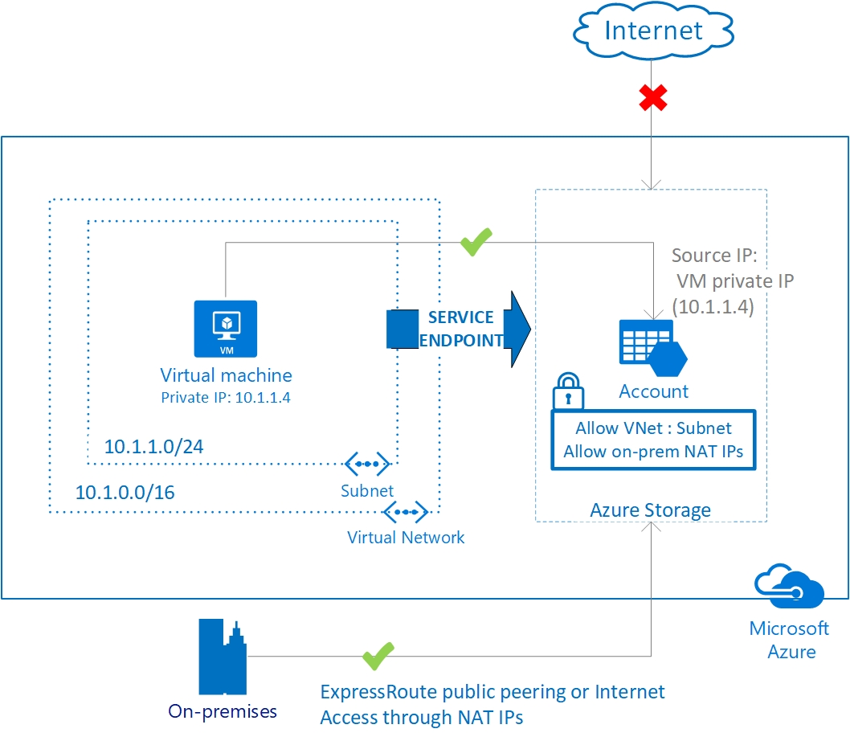

### Azure Private Endpoint

<https://docs.microsoft.com/en-us/azure/private-link/private-link-overview>

<https://www.youtube.com/watch?v=vVDql7IKneg>

Azure Private Link allows you to access Azure (PaaS) services, like Key Vault, Storage, Log Analytics, etc., over a private endpoint within your Azure VNet. The communication between the Private Link (endpoint) and your VNet continue to travel over the Microsoft’s backbone network, however your service is no longer exposed over the Internet.

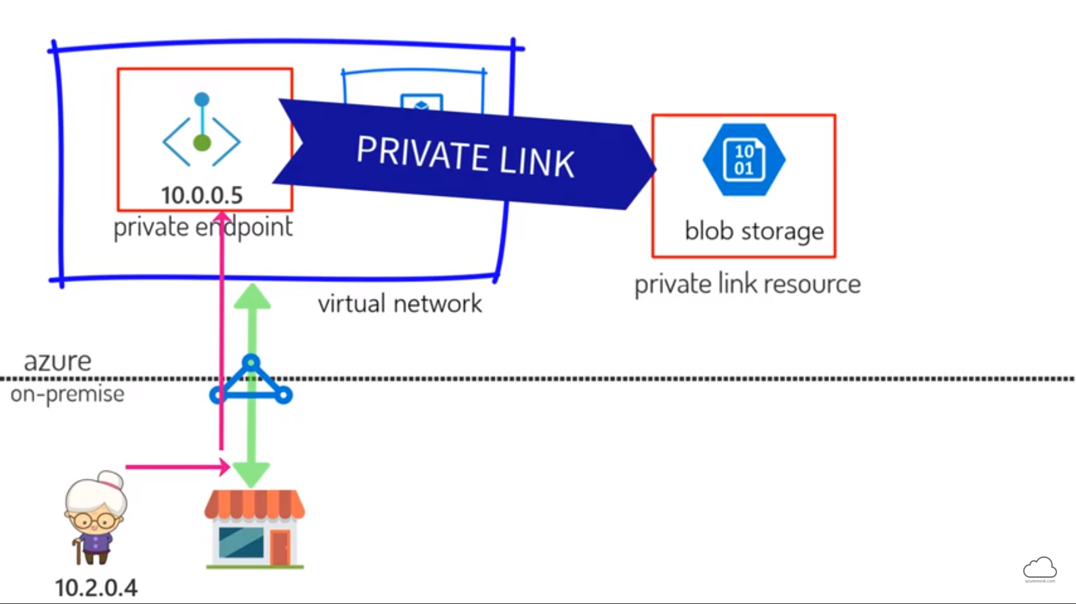

### Azure Private Links vs Service Endpoints

<https://scomandothergeekystuff.com/2020/06/22/azure-service-endpoints-versus-azure-private-links/>

* The biggest difference between **Private Links** and **Service Endpoints**, is **Public IP**s. With Private Link, there is never any Public IP created and traffic can never go through the Internet, whereas with **Service Endpoints**, you have the option to limit access.
* Second key difference with Private Link is, once enabled, you have now granted access to a specific PaaS resource within your VNet. Meaning, you can control the egress to the PaaS resource.
* Service Endpoints are much simpler to implement and significantly reduce the complexity of your VNet/Architecture design.
* **Private Link will always ensure traffic stays within your VNet**.
* Another key difference between Private Links and Service Endpoints, is cost. **There is a $0 cost to implement Service Endpoints**, as the cost is already integrated within the VNet cost itself. Whereas Private Links costs can quickly grow depending on the total ingress and egress traffic and the runtime of the link. For example, within Azure Canada Central, to have a Private Link that is available for 730 hours in a given month, and that allows 100TB of ingress and egress (for both) can run over $2,000 monthly.
  + This is something to factor when designing or implementing either solution, as Private Links will quickly add to your monthly spend.
* Another consideration is, availability, meaning Service Endpoints and Private Links are not generally available for all services, for example. There is no Service Endpoint as of writing this post, for Azure Log Analytics. However, there is a solution for Private Links for Log Analytics. Both services are available but not for all resources/services.

## Deploy dedicated Azure services into virtual networks

<https://docs.microsoft.com/en-us/azure/virtual-network/virtual-network-for-azure-services>

# Azure DNS (Route 53 )

<https://docs.microsoft.com/en-us/azure/dns/dns-overview>

Azure DNS provides the following capabilities:

* **Automatic registration of virtual machines from a virtual network that's linked to a private zone with autoregistration enabled**. The virtual machines are registered (added) to the private zone as A records pointing to their private IP addresses. When a virtual machine in a virtual network link with autoregistration enabled is deleted, Azure DNS also automatically removes the corresponding DNS record from the linked private zone.
* **Forward DNS resolution is supported across virtual networks that are linked to the private zone**. For cross-virtual network DNS resolution, there's no explicit dependency such that the virtual networks are peered with each other. However, you might want to peer virtual networks for other scenarios (for example, HTTP traffic).
* **Reverse DNS lookup is supported within the virtual-network scope**. Reverse DNS lookup for a private IP within the virtual network assigned to a private zone returns the FQDN that includes the host/record name and the zone name as the suffix.

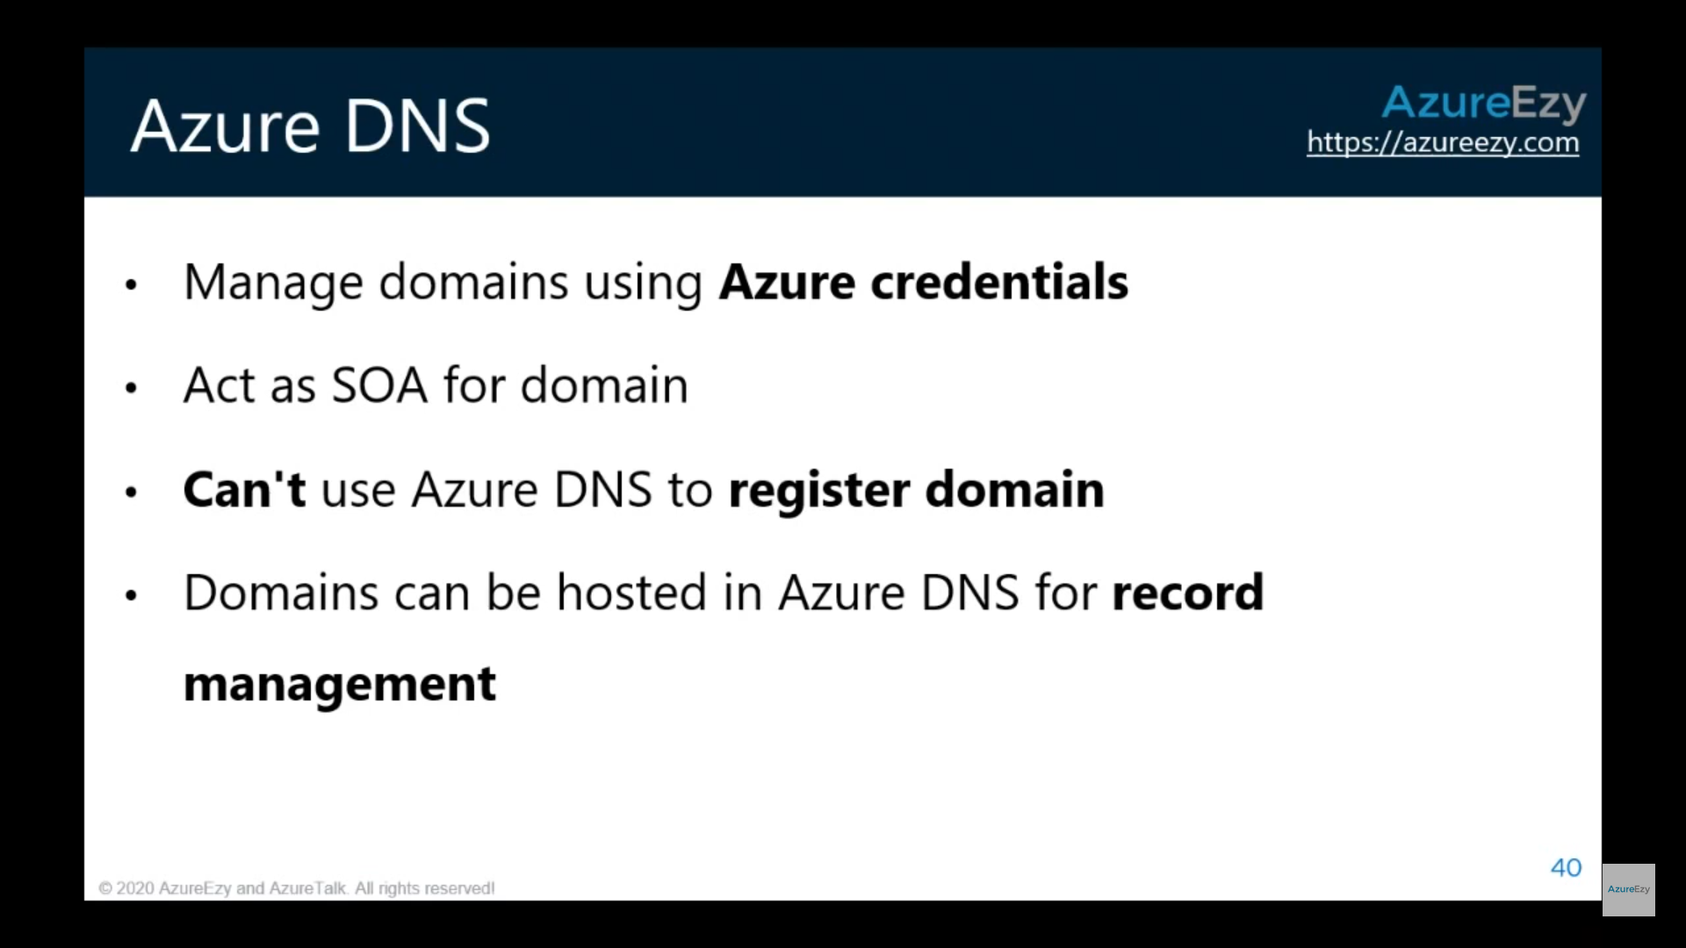

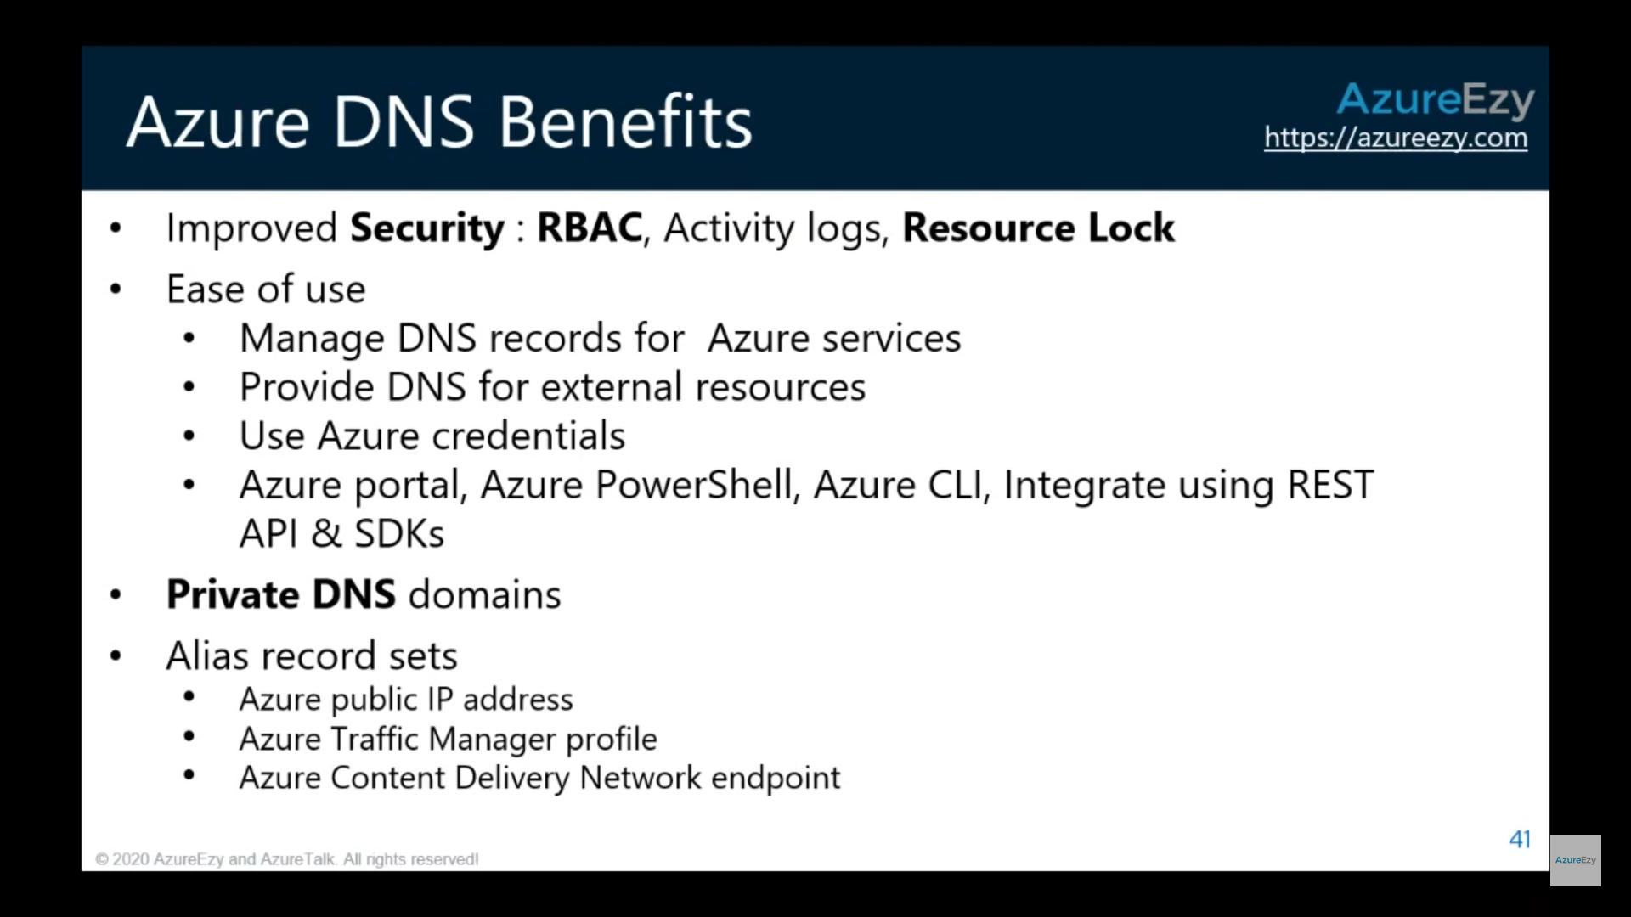

## Private DNS

<https://docs.microsoft.com/en-us/azure/dns/private-dns-overview>

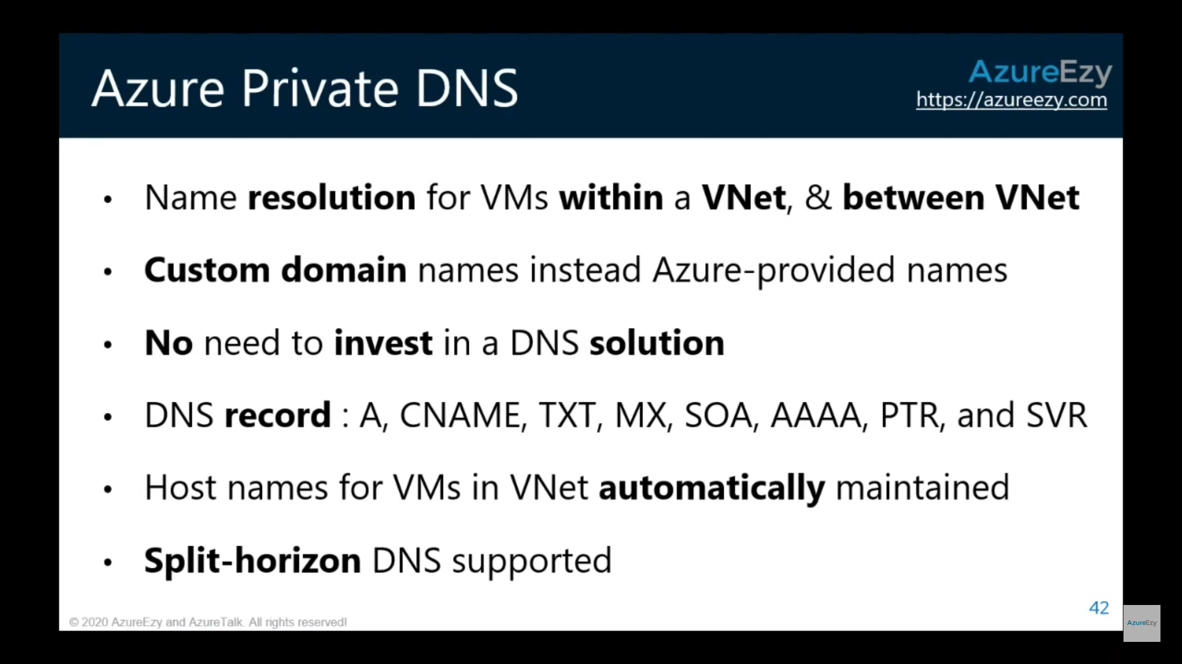

# VNET Peering

<https://docs.microsoft.com/en-us/azure/virtual-network/virtual-network-peering-overview>

<https://docs.microsoft.com/en-us/azure/virtual-network/virtual-network-troubleshoot-peering-issues>

## Global Peering

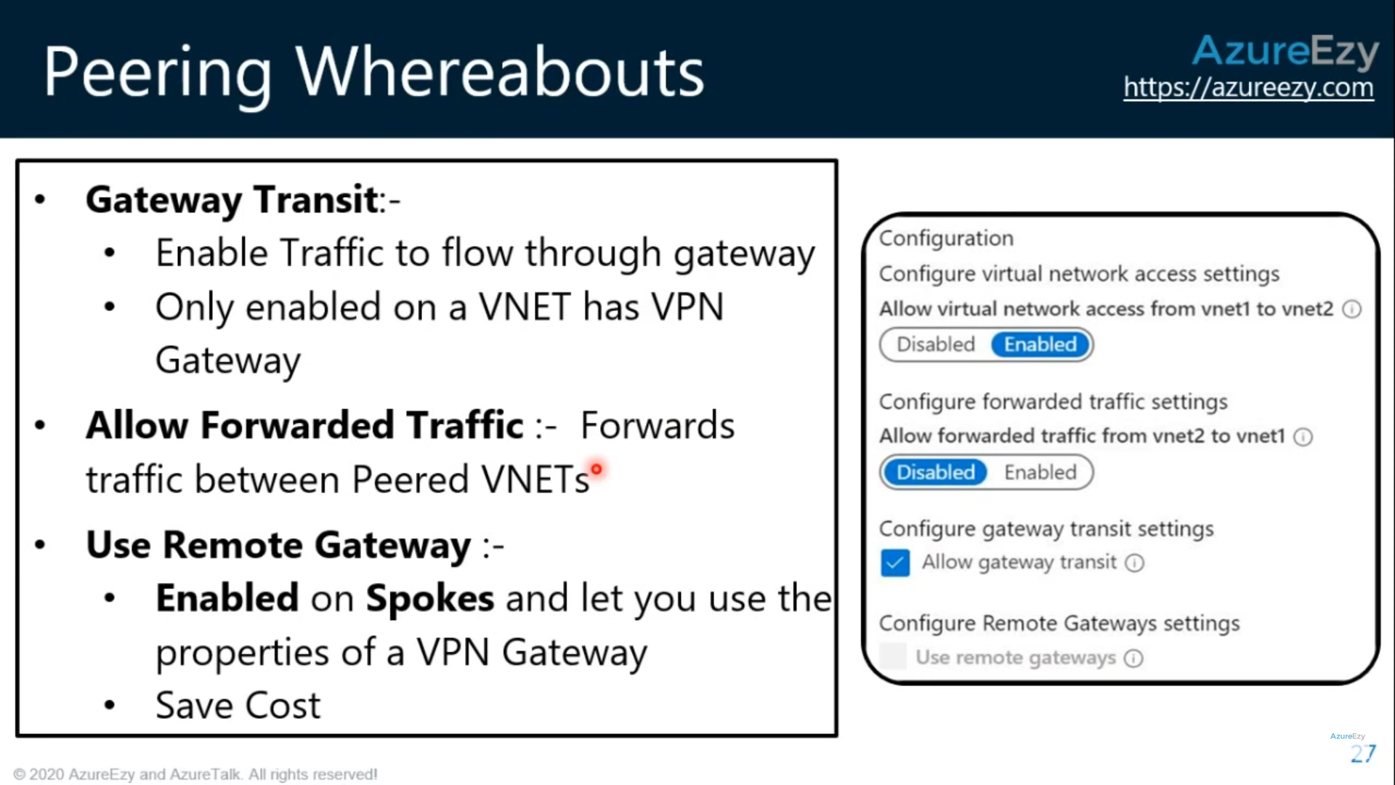

## Allow Forwarded Traffic

**This setting allows the peer’s forwarded traffic (traffic not originating from inside the peer virtual network) into your virtual network**.

## Gateway Transit

<https://docs.microsoft.com/en-us/azure/vpn-gateway/vpn-gateway-peering-gateway-transit>

[**Gateway transit**](https://docs.microsoft.com/en-us/azure/virtual-network/virtual-network-peering-overview#gateways-and-on-premises-connectivity)**is a peering property that enables one virtual network to utilize the VPN gateway in the peered virtual network for cross-premises or VNet-to-VNet connectivity.** The following diagram shows how gateway transit works with virtual network peering.

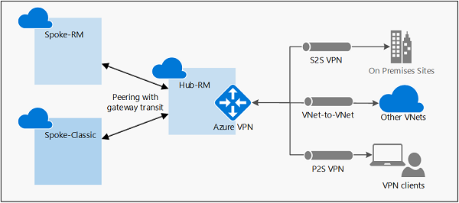

In the diagram, gateway transit allows the peered virtual networks to use the Azure VPN gateway in Hub-RM. Connectivity available on the VPN gateway, including S2S, P2S, and VNet-to-VNet connections, applies to all three virtual networks.

## Use Remote Gateway

<https://docs.microsoft.com/en-us/azure/virtual-network/virtual-network-manage-peering>

**Allows traffic from one virtual network to flow through a virtual network gateway attached to the virtual network you're peering with.** For example, the virtual network you're peering with has a VPN gateway attached that enables communication to an on-premises network. Checking this box allows traffic from this virtual network to flow through the VPN gateway attached to the peered virtual network. If you check this box, the peered virtual network must have a virtual network gateway attached to it and must have the **Allow gateway transit** checkbox checked. If you leave this box unchecked (default), traffic from the peered virtual network can still flow to this virtual network, but cannot flow through a virtual network gateway attached to this virtual network.

Only one peering for this virtual network can have this setting enabled.

## VNet Peering vs VPN Gateway

<https://azure.microsoft.com/en-in/blog/vnet-peering-and-vpn-gateways/>

|  |  |  |
| --- | --- | --- |
|  | VNet Peering | VPN Gateways |
| **Cross-region support?** | Yes – via Global VNet Peering | Yes |
| **Cross-Azure Active Directory tenant support?** | Yes, learn how to set it up in our documentation "[Create a virtual network peering](https://docs.microsoft.com/en-us/azure/virtual-network/create-peering-different-subscriptions)." | Yes, see our documentation on [VNet-to-VNet connections](https://docs.microsoft.com/en-us/azure/vpn-gateway/vpn-gateway-howto-vnet-vnet-resource-manager-portal" \l "can-i-establish-a-vnet-to-vnet-connection-across-azure-active-directory-aad-tenants" \t "_blank). |
| **Cross-subscription support?** | Yes, see our documentation "[Resource Manager, different subscriptions](https://docs.microsoft.com/en-us/azure/virtual-network/create-peering-different-subscriptions)." | Yes, see our documentation "[Configure a VNet-to-VNet VPN gateway connection by using the Azure portal](https://docs.microsoft.com/en-us/azure/vpn-gateway/vpn-gateway-howto-vnet-vnet-resource-manager-portal)." |
| **Cross-deployment model support?** | Yes, see our documentation "[different deployment models, same subscription](https://docs.microsoft.com/en-us/azure/virtual-network/create-peering-different-deployment-models)." | Yes, see our documentation "[Connect virtual networks from different deployment models using the portal](https://docs.microsoft.com/en-us/azure/vpn-gateway/vpn-gateway-connect-different-deployment-models-portal)." |
| **Limits** | You can keep up to 500 VNets with one VNet as seen in the [documentation on Networking Limits](https://docs.microsoft.com/en-us/azure/azure-subscription-service-limits#networking-limits). | Each VNet can only have one VPN Gateway. VPN Gateways depending on the SKU have type different [number of tunnel supported](https://docs.microsoft.com/en-us/azure/vpn-gateway/vpn-gateway-about-vpngateways#gwsku). |
| **Pricing** | [Ingress/Egress](https://azure.microsoft.com/en-us/pricing/details/virtual-network/) charged. | [Gateway + Egress](https://azure.microsoft.com/en-us/pricing/details/vpn-gateway/) charged. |
| **Encrypted?** | Software level encryption is recommended | Yes, [custom IPsec/IKE policy](https://docs.microsoft.com/en-us/azure/vpn-gateway/vpn-gateway-about-compliance-crypto) can be created and applied to new or existing connections. |
| **Bandwidth limitations?** | No bandwidth limitations. | Varies based on type of Gateway from [100 Mbps to 1.25Gps](https://docs.microsoft.com/en-us/azure/vpn-gateway/vpn-gateway-about-vpngateways#benchmark). |
| **Private?** | Yes, no Public IP endpoints. Routed through Microsoft backbone and is completely private. No public internet involved. | Public IP involved. |
| **Transitive relationship** | If VNet A is peered to VNet B, and VNet B is peered to VNet C, VNet A and VNet C cannot currently communicate. Spoke to spoke communication can be achieved via NVAs or Gateways in the hub VNet. See [an example](https://docs.microsoft.com/en-us/azure/architecture/reference-architectures/hybrid-networking/hub-spoke#spoke-connectivity) in our documentation. | If VNet A, VNet B, and VNet C are connected via VPN Gateways and BGP is enabled in the VNet connections, transitivity works. |
| **Typical customer scenarios** | Data replication, database failover, and other scenarios needing frequent backups of large data. | Encryption specific scenarios that are not latency sensitive and do not need high throughout. |
| **Initial setup time** | It took me 24.38 seconds, but you should give it a shot! | 30 mins to set it up |
| **FAQ link** | [VNet peering FAQ](https://docs.microsoft.com/en-us/azure/virtual-network/virtual-networks-faq#vnet-peering) | [V](https://docs.microsoft.com/en-us/azure/vpn-gateway/vpn-gateway-vpn-faq)[PN gateway FAQ](https://docs.microsoft.com/en-us/azure/vpn-gateway/vpn-gateway-vpn-faq) |

# Virtual Network Gateway

<https://docs.microsoft.com/en-us/azure/vpn-gateway/vpn-gateway-about-vpngateways>

A VPN gateway is a specific type of virtual network gateway that is used to send encrypted traffic between **an Azure virtual network and an on-premises location** over the public Internet. You can also use a VPN gateway to send encrypted traffic between **Azure virtual networks over the Microsoft network**. **Each virtual network can have only one VPN gateway (of one type each i.e. VPN and Express route).** However, you can create multiple connections to the same VPN gateway. When you create multiple connections to the same VPN gateway, all VPN tunnels share the available gateway bandwidth.

### Gateway types

<https://docs.microsoft.com/en-us/azure/vpn-gateway/vpn-gateway-about-vpn-gateway-settings>

**Each virtual network can only have one virtual network gateway of each type**. The available values for -GatewayType are:

* **Vpn :** To send encrypted traffic across the public Internet, you use the gateway type 'Vpn'. This is also referred to as a VPN gateway. **Site-to-Site, Point-to-Site, and VNet-to-VNet connections** all use a VPN gateway.
* **ExpressRoute:** To send network traffic on a private connection, you use the gateway type 'ExpressRoute'. This is also referred to as an ExpressRoute gateway and is the type of gateway used when configuring ExpressRoute.

**Note:**

1. **In general, whenever Virtual Network Gateway is mentioned it means VPN unless Express Route is mentioned.**
2. **There is a cost associated with Virtual Network Gateway device, which doesn’t exist in VNet Peering.**

|  | **Point-to-Site** | **Site-to-Site** | **ExpressRoute** |
| --- | --- | --- | --- |
| **Azure Supported Services** | Cloud Services and Virtual Machines | Cloud Services and Virtual Machines | [Services list](https://docs.microsoft.com/en-us/azure/expressroute/expressroute-faqs#supported-services) |
| **Typical Bandwidths** | Based on the gateway SKU | Typically < 1 Gbps aggregate | 50 Mbps, 100 Mbps, 200 Mbps, 500 Mbps, 1 Gbps, 2 Gbps, 5 Gbps, 10 Gbps |
| **Protocols Supported** | Secure Sockets Tunneling Protocol (SSTP), OpenVPN and IPsec | IPsec | Direct connection over VLANs, NSP's VPN technologies (MPLS, VPLS,...) |
| **Routing** | RouteBased (dynamic) | We support PolicyBased (static routing) and RouteBased (dynamic routing VPN) | BGP |
| **Connection resiliency** | active-passive | active-passive or active-active | active-active |
| **Typical use case** | Prototyping, dev / test / lab scenarios for cloud services and virtual machines | Dev / test / lab scenarios and small-scale production workloads for cloud services and virtual machines | Access to all Azure services (validated list), Enterprise-class and mission critical workloads, Backup, Big Data, Azure as a DR site |
| **SLA** | [SLA](https://azure.microsoft.com/support/legal/sla/) | [SLA](https://azure.microsoft.com/support/legal/sla/) | [SLA](https://azure.microsoft.com/support/legal/sla/) |
| **Pricing** | [Pricing](https://azure.microsoft.com/pricing/details/vpn-gateway/) | [Pricing](https://azure.microsoft.com/pricing/details/vpn-gateway/) | [Pricing](https://azure.microsoft.com/pricing/details/expressroute/) |
| **Technical Documentation** | [VPN Gateway Documentation](https://azure.microsoft.com/documentation/services/vpn-gateway/) | [VPN Gateway Documentation](https://azure.microsoft.com/documentation/services/vpn-gateway/) | [ExpressRoute Documentation](https://azure.microsoft.com/documentation/services/expressroute/) |
| **FAQ** | [VPN Gateway FAQ](https://docs.microsoft.com/en-us/azure/vpn-gateway/vpn-gateway-vpn-faq) | [VPN Gateway FAQ](https://docs.microsoft.com/en-us/azure/vpn-gateway/vpn-gateway-vpn-faq) | [ExpressRoute FAQ](https://docs.microsoft.com/en-us/azure/expressroute/expressroute-faqs) |

## VPN

### Gateway subnet

<https://www.youtube.com/watch?v=XloVU9M7UvI>

Before you create a VPN gateway, you must create a **gateway subnet**. The gateway subnet contains the IP addresses that the virtual network gateway VMs and services use. When you create your virtual network gateway, gateway VMs are deployed to the gateway subnet and configured with the required VPN gateway settings. **Never deploy anything else (for example, additional VMs) to the gateway subnet.** **The gateway subnet must be named 'GatewaySubnet' to work properly**. Naming the gateway subnet '**GatewaySubnet'** lets Azure know that this is the subnet to deploy the virtual network gateway VMs and services to.

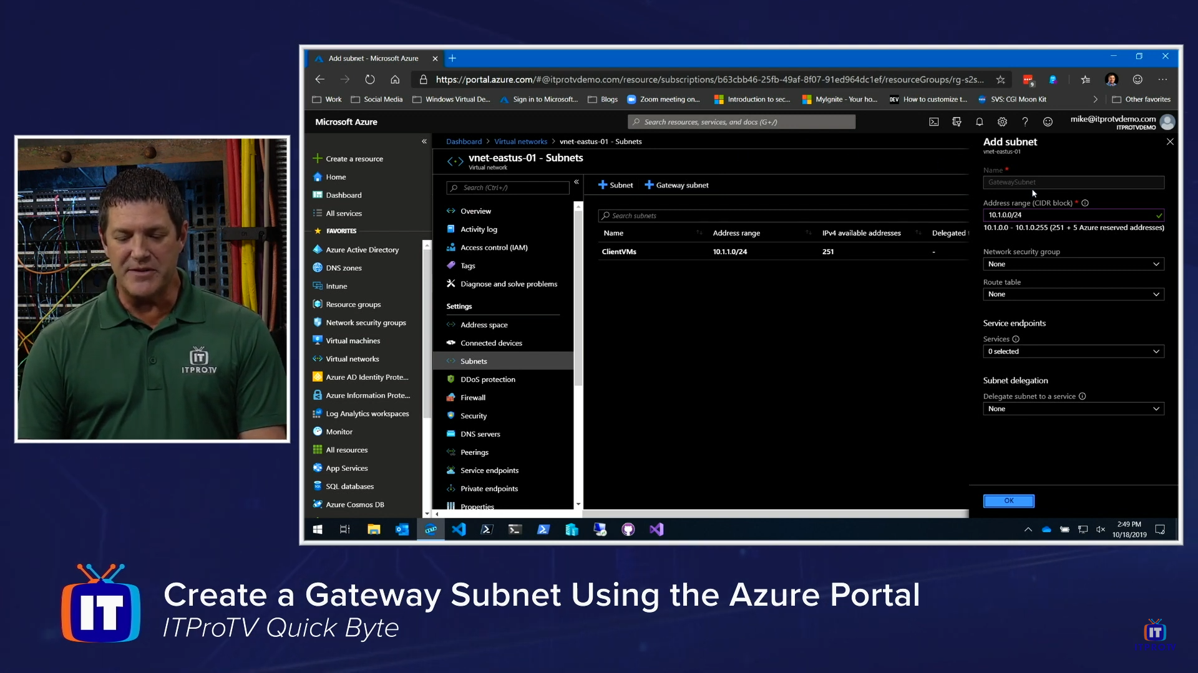

<https://docs.microsoft.com/en-us/azure/vpn-gateway/vpn-gateway-about-vpn-gateway-settings#requirements>

While you can create a **gateway subnet as small as /29**, we recommend that you create a **gateway subnet of /27 or larger (/27, /26 etc.)** if you have the available address space to do so. This will accommodate most configurations.

### VPN Types based on Connectivity:

<https://docs.microsoft.com/en-us/azure/vpn-gateway/design>

### Point to Site(P2S):

<https://docs.microsoft.com/en-us/azure/vpn-gateway/point-to-site-about>

<https://www.youtube.com/watch?v=Yshpo6V1qUQ>

<https://www.youtube.com/watch?v=AkhHgRjl_yU>

A Point-to-Site (P2S) VPN gateway connection lets you create a secure connection to your virtual network from an individual client computer. A P2S connection is established by starting it from the client computer.

**P2S VPN is also a useful solution to use instead of S2S VPN when you have only a few clients that need to connect to a VNet.**

Point-to-site VPN can use one of the following protocols:

* **OpenVPN® Protocol**, an SSL/TLS based VPN protocol.
* Secure Socket Tunneling Protocol (SSTP), a proprietary TLS-based VPN protocol.
* IKEv2 VPN, a standards-based IPsec VPN solution.

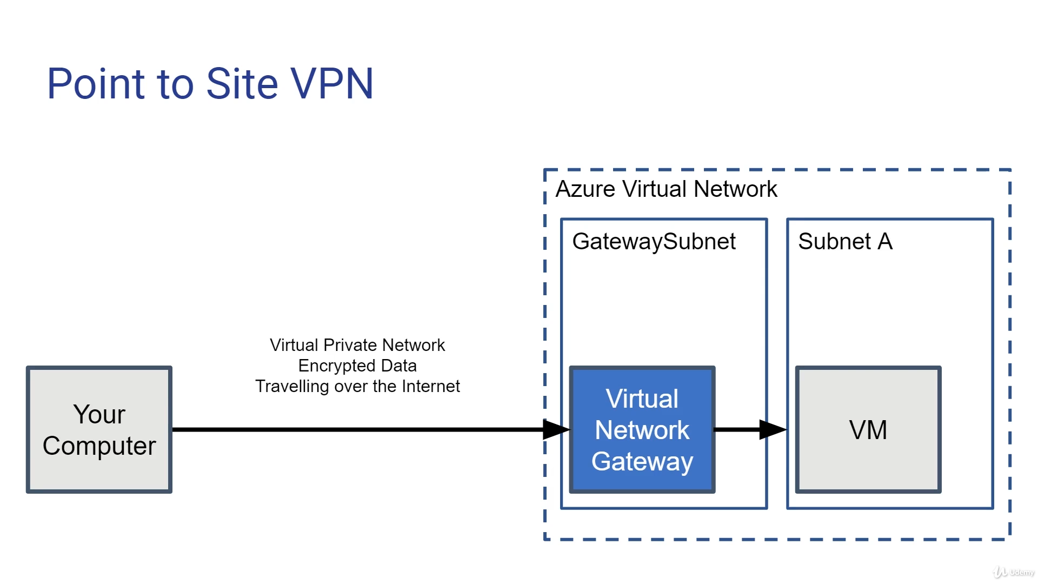

### Site to Site (S2S):

<https://www.youtube.com/watch?v=7AAqhsNJWkw>

Unlike a software in P2S in case of S2S a VPN gateway device is required at the site from where we need to create the connection. However, it has advantages like redundancy, active-active etc

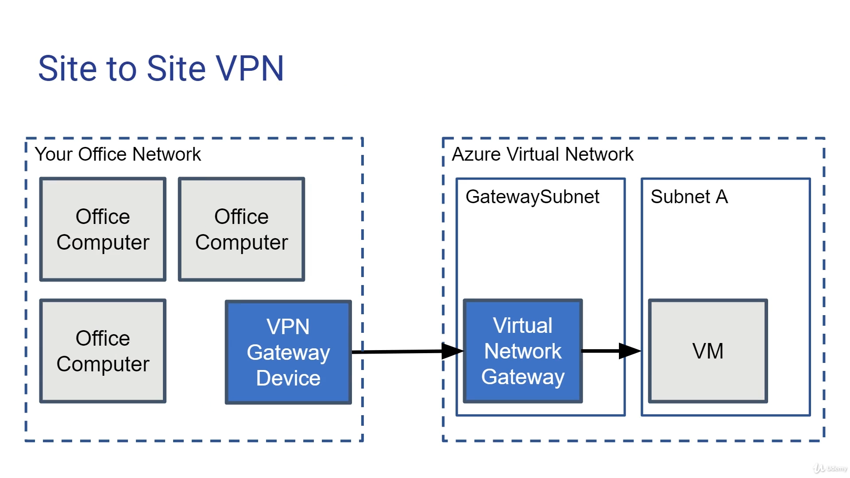

One needs a **Local Network Gateway** in case of Site to Site VPN Gateway.

<https://www.youtube.com/watch?v=K0hgCWIbC1A>

And then create a **VPN Connection** to connect **Local Network Gateway** to **GatewaySubnet**

<https://docs.microsoft.com/en-us/azure/vpn-gateway/vpn-gateway-howto-site-to-site-resource-manager-portal#CreateConnection>

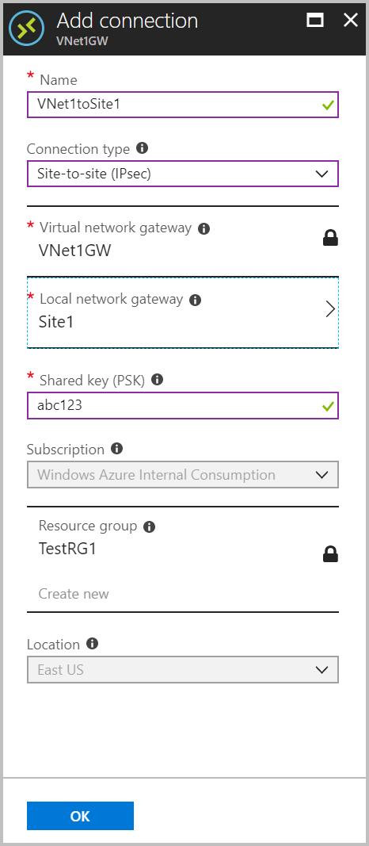

### VNet-to-VNet (VNet2VNet)

<https://docs.microsoft.com/en-us/azure/vpn-gateway/vpn-gateway-howto-vnet-vnet-resource-manager-portal>

When you connect a virtual network to another virtual network with a VNet-to-VNet connection type (VNet2VNet), it's similar to creating a Site-to-Site IPsec connection to an on-premises location. Both connection types use a VPN gateway to provide a secure tunnel with IPsec/IKE and function the same way when communicating. However, they differ in the way the local network gateway is configured.

You can also connect your VNets by using VNet peering. VNet peering doesn't use a VPN gateway and has different constraints.

You may want to connect virtual networks by using a VNet-to-VNet connection for the following reasons:

* You can set up your own geo-replication or synchronization with secure connectivity without going over internet-facing endpoints.
* With Azure Traffic Manager and Azure Load Balancer, you can set up highly available workload with geo-redundancy across multiple Azure regions. For example, you can set up SQL Server Always On availability groups across multiple Azure regions.
* Within the same region, you can set up multi-tier applications with multiple virtual networks that are connected together because of isolation or administrative requirements.

### Virtual Network Gateway SKUs by feature set

The new VPN gateway SKUs streamline the feature sets offered on the gateways:

| Gateway SKUs by feature set | |
| --- | --- |
| **SKU** | **Features** |
| **Basic** (\*\*) | **Route-based VPN**: 10 tunnels for S2S/connections; no RADIUS authentication for P2S; no IKEv2 for P2S **Policy-based VPN**: (IKEv1): 1 S2S/connection tunnel; no P2S |
| **All Generation1 and Generation2 SKUs except Basic** | **Route-based VPN**: up to 30 tunnels (\*), P2S, BGP, active-active, custom IPsec/IKE policy, ExpressRoute/VPN coexistence |

Due to the differences in SLAs and feature sets, we recommend the following SKUs for production vs. dev-test:

| Gateway SKUs - Production vs. Dev-Test Workloads | |
| --- | --- |
| **Workload** | **SKUs** |
| **Production, critical workloads** | **All Generation1 and Generation2 SKUs except Basic** |
| **Dev-test or proof of concept** | Basic (\*\*) |

## VPN types based on network routing

<https://docs.microsoft.com/en-us/azure/vpn-gateway/vpn-gateway-about-vpn-gateway-settings#vpntype>

When you create the virtual network gateway for a VPN gateway configuration, you must specify a VPN type. The VPN type that you choose depends on the connection topology that you want to create.

Once a virtual network gateway has been created, you can't change the VPN type. You have to delete the virtual network gateway and create a new one. There are two VPN types:

### PolicyBased:

PolicyBased VPNs were previously called static routing gateways in the classic deployment model. When using a PolicyBased VPN, keep in mind the following limitations:

* **PolicyBased VPNs can only be used on the Basic gateway SKU**. This VPN type is not compatible with other gateway SKUs.
* You can have only 1 tunnel when using a PolicyBased VPN.
* You can only use PolicyBased VPNs for S2S connections, and only for certain configurations. **Most VPN Gateway configurations require a RouteBased VPN**.

### **RouteBased**:

RouteBased VPNs were previously called dynamic routing gateways in the classic deployment model. RouteBased VPNs use "routes" in the IP forwarding or routing table to direct packets into their corresponding tunnel interfaces. The tunnel interfaces then encrypt or decrypt the packets in and out of the tunnels. The policy (or traffic selector) for RouteBased VPNs are configured as any-to-any (or wild cards). The value for a RouteBased VPN type is RouteBased.

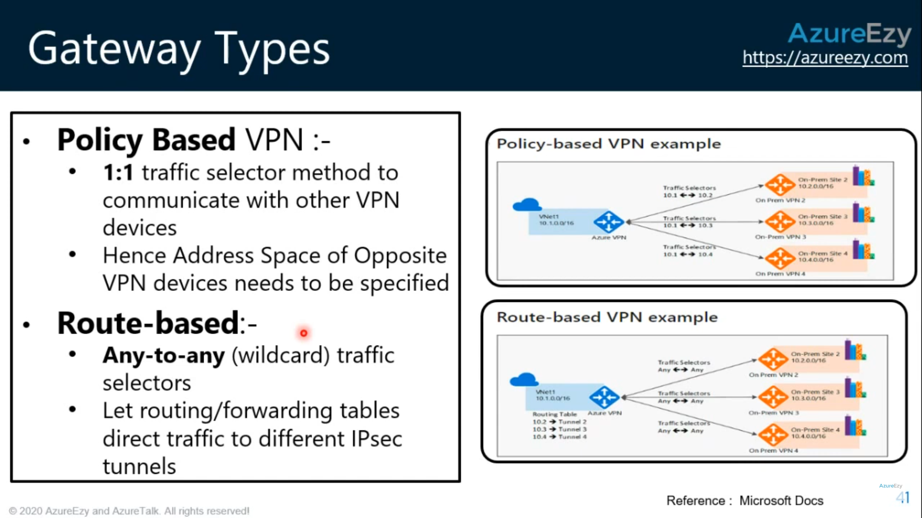

## Express Route

<https://docs.microsoft.com/en-us/azure/expressroute/expressroute-introduction>

ExpressRoute lets you extend your on-premises networks into the Microsoft cloud over a **private connection** facilitated by a connectivity provider.

## Key benefits

* Layer 3 connectivity **between your on-premises network and the Microsoft Cloud through a connectivity provider**. Connectivity can be from an any-to-any (IPVPN) network, a point-to-point Ethernet connection, or through a virtual cross-connection via an Ethernet exchange.
* Connectivity to **Microsoft cloud services across all regions in the geopolitical region**.
* Global connectivity to Microsoft services across all regions with the ExpressRoute premium add-on.
* Dynamic routing between your network and Microsoft via BGP.
* Built-in redundancy in every peering location for higher reliability.
* Connection uptime [SLA](https://azure.microsoft.com/support/legal/sla/).
* QoS support for Skype for Business.

Each ExpressRoute circuit consists of two connections to two Microsoft Enterprise edge routers (MSEEs) at an ExpressRoute Location from the connectivity provider/your network edge. Microsoft requires dual BGP connection from the connectivity provider/your network edge – one to each MSEE. You may choose not to deploy redundant devices/Ethernet circuits at your end. However, connectivity providers use redundant devices to ensure that your connections are handed off to Microsoft in a redundant manner. A redundant Layer 3 connectivity configuration is a requirement for our SLA to be valid.

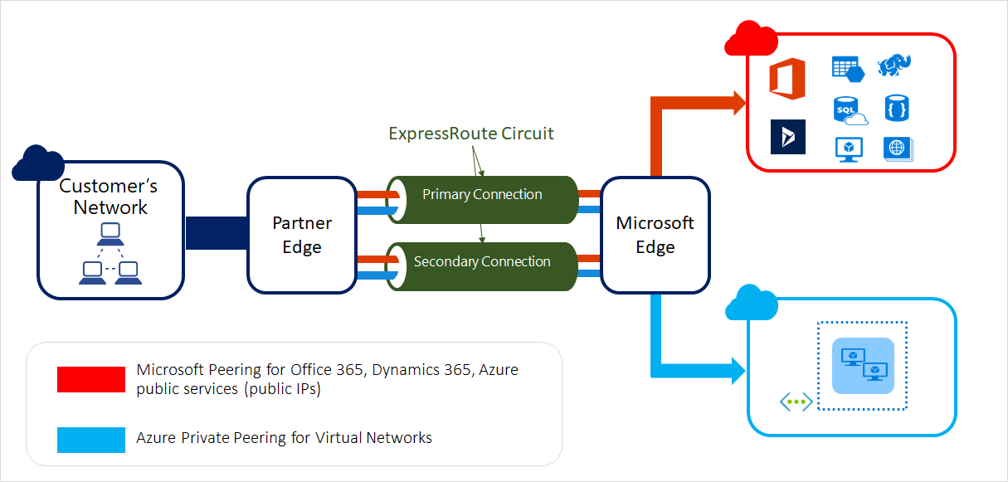

<https://docs.microsoft.com/en-us/azure/expressroute/expressroute-about-virtual-network-gateways>

ExpressRoute virtual network gateways can use the following SKUs:

* Standard
* HighPerformance
* UltraPerformance

### Gateway subnet

Before you create an ExpressRoute gateway, you must create a gateway subnet. The gateway subnet contains the IP addresses that the virtual network gateway VMs and services use. When you create your virtual network gateway, gateway VMs are deployed to the gateway subnet and configured with the required ExpressRoute gateway settings. Never deploy anything else (for example, additional VMs) to the gateway subnet. The gateway subnet must be named 'GatewaySubnet' to work properly. Naming the gateway subnet 'GatewaySubnet' lets Azure know that this is the subnet to deploy the virtual network gateway VMs and services to.

While you can create a **gateway subnet as small as /29**, we recommend that you create a **gateway subnet of /27 or larger (/27, /26 etc.)** if you have the available address space to do so. This will accommodate most configurations.

### Express Route Direct

<https://docs.microsoft.com/en-us/azure/expressroute/expressroute-erdirect-about>

ExpressRoute Direct provides dual 100 Gbps or 10 Gbps connectivity, which supports Active/Active connectivity at scale.

Key features that ExpressRoute Direct provides include, but aren't limited to:

* Massive Data Ingestion into services like Storage and Cosmos DB
* Physical isolation for industries that are regulated and require dedicated and isolated connectivity like: Banking, Government, and Retail
* Granular control of circuit distribution based on business unit

|  |  |
| --- | --- |
| **ExpressRoute using a service provider** | **ExpressRoute Direct** |
| Utilizes service providers to enable fast onboarding and connectivity into existing infrastructure | Requires 100 Gbps/10 Gbps infrastructure and full management of all layers |
| Integrates with hundreds of providers including Ethernet and MPLS | Direct/Dedicated capacity for regulated industries and massive data ingestion |
| Circuits SKUs from 50 Mbps to 10 Gbps | Customer may select a combination of the following circuit SKUs on 100 Gbps ExpressRoute Direct:   * 5 Gbps * 10 Gbps * 40 Gbps * 100 Gbps   Customer may select a combination of the following circuit SKUs on 10 Gbps ExpressRoute Direct:   * 1 Gbps * 2 Gbps * 5 Gbps * 10 Gbps |
| Optimized for single tenant | **Optimized for single tenant with multiple business units and multiple work environments** |

### Express Route FastPath

<https://docs.microsoft.com/en-us/azure/expressroute/about-fastpath>

ExpressRoute virtual network gateway is designed to exchange network routes and route network traffic. FastPath is designed to improve the data path performance between your on-premises network and your virtual network. When enabled, FastPath sends network traffic directly to virtual machines in the virtual network, bypassing the gateway.

### Express Route Global Reach

<https://docs.microsoft.com/en-us/azure/expressroute/expressroute-global-reach>

ExpressRoute Global Reach is designed to complement your service provider’s WAN implementation and connect your branch offices across the world. For example, if your service provider primarily operates in the United States and has linked all of your branches in the U.S., but the service provider doesn’t operate in Japan and Hong Kong, with ExpressRoute Global Reach you can work with a local service provider and Microsoft will connect your branches there to the ones in the U.S. using ExpressRoute and our global network.

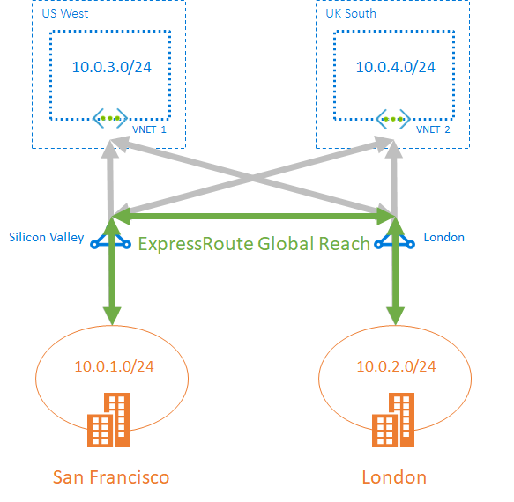

# Azure Relay

<https://docs.microsoft.com/en-us/azure/azure-relay/relay-what-is-it>

The Azure Relay service enables you to securely expose services that run in your corporate network to the public cloud. You can do so without opening a port on your firewall or making intrusive changes to your corporate network infrastructure.

Azure Relay differs from network-level integration technologies such as VPN. **An Azure relay can be scoped to a single application endpoint on a single machine.** The VPN technology is far more intrusive, as it relies on altering the network environment.

Azure Relay has two features:

* [**Hybrid Connections**](https://docs.microsoft.com/en-us/azure/azure-relay/relay-what-is-it#hybrid-connections)- Uses the open standard web sockets enabling multi-platform scenarios. **You can use it on any platform and in any language**. Hybrid Connections feature in Azure Relay is based on HTTP and WebSockets protocols. It allows you to send requests and receive responses over web sockets or HTTP(S). This feature is compatible with WebSocket API in common web browsers.
* **WCF Relays** - Uses **Windows Communication Foundation (WCF)** to enable remote procedure calls. WCF Relay is the legacy relay offering that many customers already use with their WCF programming models.

## Hybrid Connections

Hybrid Connections is both a service in Azure and a feature in Azure App Service. As a service, it has uses and capabilities beyond those that are used in App Service.

Hybrid Connections can be used to access application resources in any network that can make outbound calls to Azure over port 443. Each Hybrid Connection correlates to a single TCP host and port combination. This enables your apps to access resources on any OS, provided it is a TCP endpoint. The Hybrid Connections feature does not know or care what the application protocol is, or what you are accessing. It simply provides network access.

### Azure App Service Hybrid Connections

<https://docs.microsoft.com/en-us/azure/app-service/app-service-hybrid-connections>

Hybrid Connections requires a relay agent to be deployed where it can reach both the desired endpoint as well as to Azure. The relay agent, **Hybrid Connection Manager (HCM)**, calls out to Azure Relay over port 443. From the web app site, the App Service infrastructure also connects to Azure Relay on your application's behalf. Through the joined connections, your app is able to access the desired endpoint. The connection uses TLS 1.2 for security and shared access signature (SAS) keys for authentication and authorization.

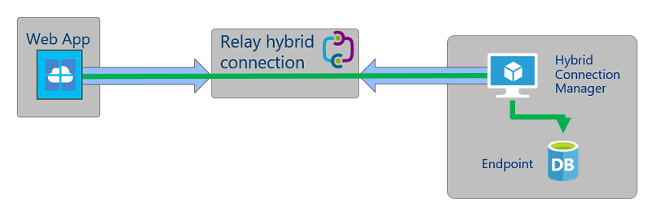

**App Service Hybrid Connection benefits:**

* Apps can access on-premises systems and services securely.
* No gateways required
* **Access resources in private networks that are not connected to Azure with a VPN or ExpressRoute** ( <https://docs.microsoft.com/en-us/azure/app-service/networking-features> )

# Data gateway

<https://docs.microsoft.com/en-us/data-integration/gateway/service-gateway-onprem>

The on-premises data gateway acts as a bridge. It provides quick and secure data transfer between on-premises data, which is data that isn't in the cloud, and several Microsoft cloud services. These services include Power BI, Power Apps, Power Automate, Azure Analysis Services, and Azure Logic Apps.

**Data gateway in general can be assumed to be working exclusively for Azure Logic Apps as far as cloud offerings are concerned, unless you are using other MS SAS offerings.**

<https://docs.microsoft.com/en-us/data-integration/gateway/service-gateway-onprem-indepth>

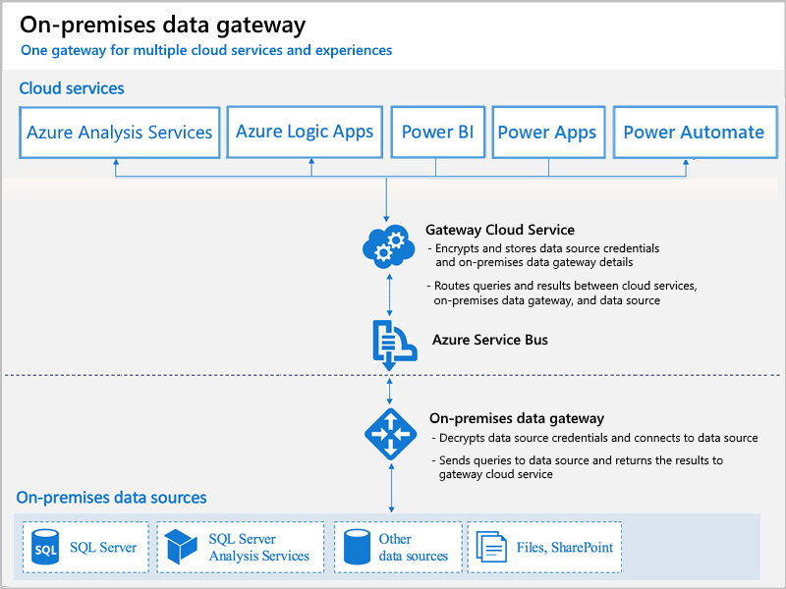

# Virtual WAN

<https://docs.microsoft.com/en-us/azure/virtual-wan/virtual-wan-about>

Azure Virtual WAN is a networking service that brings many networking, security, and routing functionalities together to provide a single operational interface. These functionalities include

* branch connectivity (via connectivity automation from Virtual WAN Partner devices such as SD-WAN or VPN CPE),
* Site-to-site VPN connectivity,
* remote user VPN (Point-to-site) connectivity,
* private (ExpressRoute) connectivity,
* intra-cloud connectivity (transitive connectivity for virtual networks),
* VPN ExpressRoute inter-connectivity,
* routing,
* Azure Firewall, and
* encryption for private connectivity.

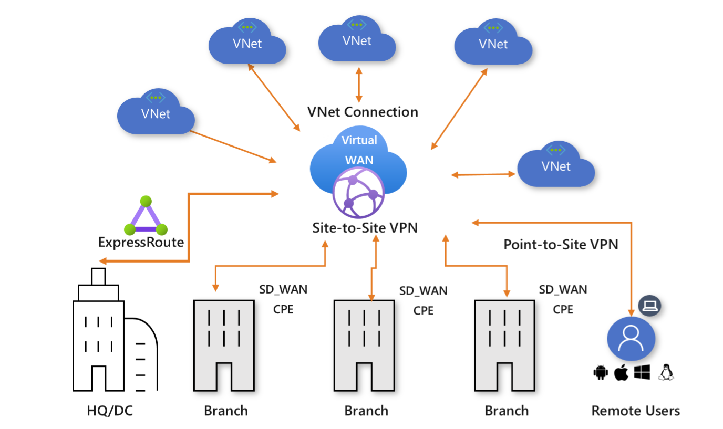

| **Virtual WAN type** | **Hub type** | **Available configurations** |
| --- | --- | --- |
| Basic | Basic | Site-to-site VPN only |
| Standard | Standard | ExpressRoute User VPN (P2S) VPN (site-to-site) Inter-hub and VNet-to-VNet transiting through the virtual hub |

TASK:

<https://docs.microsoft.com/en-us/azure/virtual-network/virtual-network-multiple-ip-addresses-portal#os-config>

# Network Security Monitoring

## Azure Security Center

<https://docs.microsoft.com/en-in/azure/security-center/security-center-introduction>

### Azure Sentinel

<https://docs.microsoft.com/en-us/azure/sentinel/overview>

Microsoft Azure Sentinel is a scalable, cloud-native, **security information event management (SIEM)** and **security orchestration automated response (SOAR)** solution. Azure Sentinel delivers intelligent security analytics and threat intelligence across the enterprise, providing a single solution for alert detection, threat visibility, proactive hunting, and threat response.

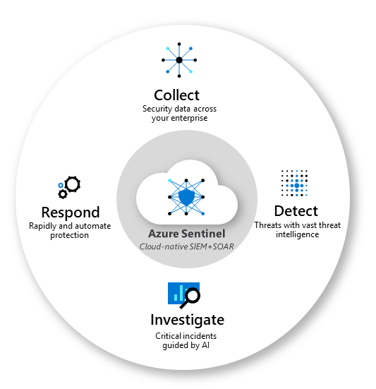

# Azure Network Watcher

<https://docs.microsoft.com/en-us/azure/network-watcher/network-watcher-monitoring-overview>

Azure Network Watcher provides tools to monitor, diagnose, view metrics, and enable or disable logs for resources in an Azure virtual network. Network Watcher is designed to monitor and repair the network health of IaaS (Infrastructure-as-a-Service) products which includes Virtual Machines, Virtual Networks, Application Gateways, Load balancers, etc. Note: It is not intended for and will not work for PaaS monitoring or Web analytics.

## Traffic Analytics

<https://docs.microsoft.com/en-us/azure/network-watcher/traffic-analytics>

Traffic Analytics is a cloud-based solution that provides visibility into user and application activity in cloud networks. Traffic analytics analyzes Network Watcher network security group (NSG) flow logs to provide insights into traffic flow in your Azure cloud.

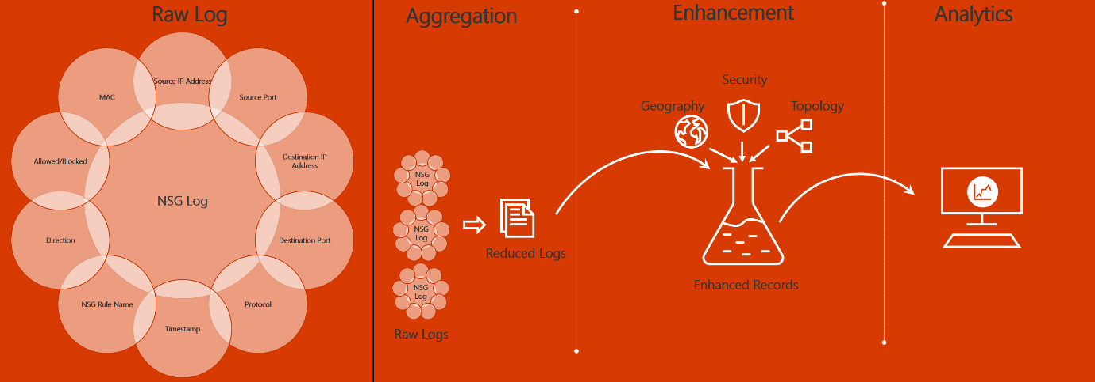

For example, Host 1 (IP address: 10.10.10.10) communicating to Host 2 (IP address: 10.10.20.10), 100 times over a period of 1 hour using port (for example, 80) and protocol (for example, http). The reduced log has one entry, that Host 1 & Host 2 communicated 100 times over a period of 1 hour using port 80 and protocol HTTP, instead of having 100 entries.

# FAQs

<https://docs.microsoft.com/en-us/azure/virtual-network/virtual-networks-faq>

## Virtual Network basics

1. Can I have public IP addresses in my VNets?
2. Are there any restrictions on using IP addresses within these subnets?

Azure reserves 5 IP addresses within each subnet. These are x.x.x.0-x.x.x.3 and the last address of the subnet. x.x.x.1-x.x.x.3 is reserved in each subnet for Azure services.

x.x.x.0: Network address

x.x.x.1: Reserved by Azure for the default gateway

x.x.x.2, x.x.x.3: Reserved by Azure to map the Azure DNS IPs to the VNet space

x.x.x.255: Network broadcast address

1. 3.How small and how large can VNets and subnets be?

The smallest supported IPv4 subnet is /29, and the largest is /8 (using CIDR subnet definitions). IPv6 subnets must be exactly /64 in size.

1. Can I specify custom routing policies on my VNets and subnets?

Yes. You can create a route table and associate it to a subnet. For more information about routing in Azure, see Routing overview.

1. Do VNets support multicast or broadcast?

No. Multicast and broadcast are not supported.

1. Can I ping my default routers within a VNet?

No.

1. Can I use tracert to diagnose connectivity?

No.

1. Can I modify the size of my subnet after I create it?

Yes. You can add, remove, expand, or shrink a subnet if there are no VMs or services deployed within it.

1. Can a VNet span regions?

No. A VNet is limited to a single region. A virtual network does, however, span availability zones.

## Name Resolution (DNS)

1. Can I specify DNS servers for a VNet?

Yes. You can specify DNS server IP addresses in the VNet settings. The setting is applied as the default DNS server(s) for all VMs in the VNet.

1. Can I override my DNS settings on a per-VM or cloud service basis?

Yes. You can set DNS servers per VM or cloud service to override the default network settings. However, it's recommended that you use network-wide DNS as much as possible.

1. Can I bring my own DNS suffix?

No. You cannot specify a custom DNS suffix for your VNets.

## Connecting virtual machines

1. Can I deploy VMs to a VNet?

Yes. All network interfaces (NIC) attached to a VM deployed through the Resource Manager deployment model must be connected to a VNet. VMs deployed through the classic deployment model can optionally be connected to a VNet.

1. Can I reserve a private IP address for a VM that I will create at a later time?

No. You cannot reserve a private IP address. If a private IP address is available, it is assigned to a VM or role instance by the DHCP server. The VM may or may not be the one that you want the private IP address assigned to. You can, however, change the private IP address of an already created VM, to any available private IP address.

1. Do private IP addresses change for VMs in a VNet?

It depends. If the VM was deployed through Resource Manager, no, regardless of whether the **IP address was assigned with the static or dynamic allocation method**. If the VM was deployed through the classic deployment model, dynamic IP addresses can change when a VM is started after having been in the stopped (deallocated) state. The address is released from a VM deployed through either deployment model when the VM is deleted.

1. Can I manually assign IP addresses to NICs within the VM operating system?

Yes, but it's not recommended unless necessary, such as when assigning multiple IP addresses to a virtual machine. For details, see Adding multiple IP addresses to a virtual machine. If the IP address assigned to an Azure NIC attached to a VM changes, and the IP address within the VM operating system is different, you lose connectivity to the VM.

1. If I stop a Cloud Service deployment slot or shutdown a VM from within the operating system, what happens to my IP addresses?

Nothing. The IP addresses (public VIP, public, and private) remain assigned to the cloud service deployment slot or VM.

1. Can I configure a static MAC address for my VM?

No. A MAC address cannot be statically configured.

1. Will the MAC address remain the same for my VM once it's created?

Yes, the MAC address remains the same for a VM deployed through both the Resource Manager and classic deployment models until it's deleted. Previously, the MAC address was released if the VM was stopped (deallocated), but now the MAC address is retained even when the VM is in the deallocated state. The MAC address remains assigned to the network interface until the network interface is deleted or the private IP address assigned to the primary IP configuration of the primary network interface is changed.

1. Can I move VMs from one subnet to another subnet in a VNet without redeploying?

Yes. You can find more information in the How to move a VM or role instance to a different subnet article.

## Azure services that connect to VNets

1. Can I move my services in and out of VNets?

No. You cannot move services in and out of VNets. To move a resource to another VNet, you have to delete and redeploy the resource.

## VNet peering

1. What are the constraints related to Global VNet Peering and Load Balancers?

If the two virtual networks in two different regions are peered over Global VNet Peering, you cannot connect to resources that are behind a Basic Load Balancer through the Front End IP of the Load Balancer. This restriction does not exist for a Standard Load Balancer. The following resources can use Basic Load Balancers which means you cannot reach them through the Load Balancer's Front End IP over Global VNet Peering. You can however use Global VNet peering to reach the resources directly through their private VNet IPs, if permitted.

VMs behind Basic Load Balancers

Virtual machine scale sets with Basic Load Balancers

Redis Cache

Application Gateway (v1) SKU

Service Fabric

SQL MI

API Management

Active Directory Domain Service (ADDS)

Logic Apps

HDInsight

Azure Batch

App Service Environment

You can connect to these resources via ExpressRoute or VNet-to-VNet through VNet Gateways.

1. Can I enable VNet Peering if my virtual networks belong to subscriptions within different Azure Active Directory tenants?

Yes. It is possible to establish VNet Peering (whether local or global) if your subscriptions belong to different Azure Active Directory tenants. You can do this via PowerShell or CLI. Portal is not yet supported.

1. My VNet peering connection is in Initiated state, why can't I connect?

If your peering connection is in an Initiated state, this means you have created only one link. A bidirectional link must be created in order to establish a successful connection. For example, to peer VNet A to VNet B, a link must be created from VNetA to VNetB and from VNetB to VNetA. Creating both links will change the state to Connected.

1. My VNet peering connection is in Disconnected state, why can't I create a peering connection?

If your VNet peering connection is in a Disconnected state, it means one of the links created was deleted. In order to re-establish a peering connection, you will need to delete the link and recreate it.

1. Can I peer two VNets with matching or overlapping address ranges?

No. Address spaces must not overlap to enable VNet Peering.

1. How much do VNet peering links cost?

There is no charge for creating a VNet peering connection. Data transfer across peering connections is charged.

1. Is VNet peering traffic encrypted?

No. Traffic between resources in peered VNets is private and isolated. It remains completely on the Microsoft Backbone.

1. If I peer VNetA to VNetB and I peer VNetB to VNetC, does that mean VNetA and VNetC are peered?

No. Transitive peering is not supported. You must peer VNetA and VNetC for this to take place.

1. Are there any bandwidth limitations for peering connections?

No. VNet peering, whether local or global, does not impose any bandwidth restrictions. Bandwidth is only limited by the VM or the compute resource.

# Load Balancers

<https://docs.microsoft.com/en-us/azure/architecture/guide/technology-choices/load-balancing-overview>

<https://www.youtube.com/watch?v=FVJUZkmuozY>

## Application Delivery

<https://docs.microsoft.com/en-us/azure/architecture/guide/technology-choices/load-balancing-overview>

The following table summarizes the Azure load balancing services by these categories:

|  |  |  |
| --- | --- | --- |
| HTTP(S) VERSUS NON-HTTP(S) | | |
| Service | **Global/regional** | **Recommended traffic** |
| Azure Front Door | Global | HTTP(S) |
| Traffic Manager | Global | non-HTTP(S) |
| Application Gateway | Regional | HTTP(S) |
| Azure Load Balancer | Global | non-HTTP(S) |

**The Azure Application Gateway service is a region-specific resource**. It won’t fulfill the requirement to provide redundancy in the event of an Azure region failure.

## Decision tree for load balancing in Azure

When selecting the load-balancing options, here are some factors to consider:

* **Traffic type**. Is it a web (HTTP/HTTPS) application? Is it public facing or a private application?
* **Global versus. regional**. Do you need to load balance VMs or containers within a virtual network, or load balance scale unit/deployments across regions, or both?
* **Availability**. What is the service [SLA](https://azure.microsoft.com/support/legal/sla/)?
* **Cost**. See [Azure pricing](https://azure.microsoft.com/pricing/). In addition to the cost of the service itself, consider the operations cost for managing a solution built on that service.
* **Features and limits**. What are the overall limitations of each service?

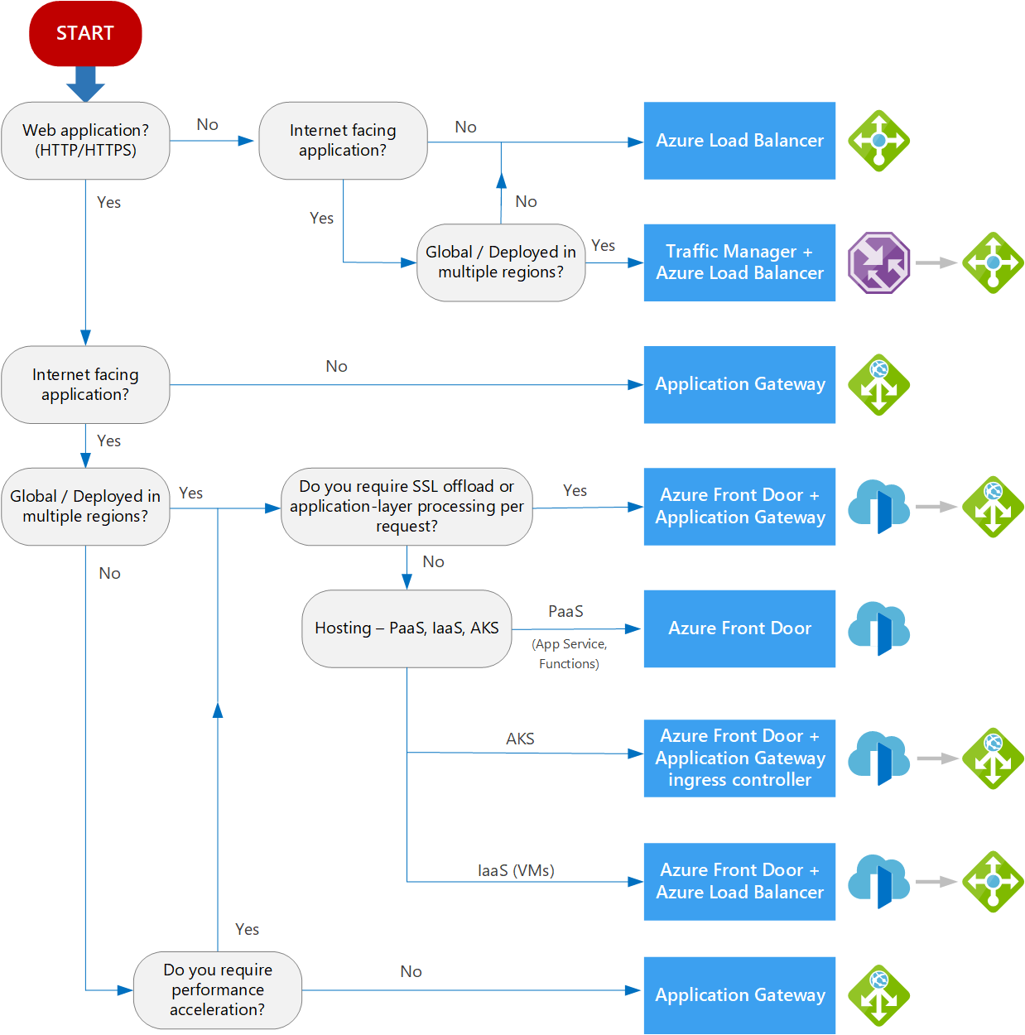

## Azure Load Balancer

<https://docs.microsoft.com/en-us/azure/load-balancer/load-balancer-overview>

[Azure Load Balancer](https://docs.microsoft.com/en-us/azure/load-balancer/load-balancer-overview) is a high-performance, low-latency Layer 4 load-balancing service (inbound and outbound) for all UDP and TCP protocols. It is built to handle millions of requests per second while ensuring your solution is highly available. Azure Load Balancer is **zone-redundant**, ensuring high availability across Availability Zones.

A [**public load balancer**](https://docs.microsoft.com/en-us/azure/load-balancer/components#frontend-ip-configurations) can provide outbound connections for virtual machines (VMs) inside your virtual network. These connections are accomplished by translating their private IP addresses to public IP addresses. Public Load Balancers are used to load balance internet traffic to your VMs.

An [**internal (or private) load balancer**](https://docs.microsoft.com/en-us/azure/load-balancer/components#frontend-ip-configurations) is used where private IPs are needed at the frontend only. Internal load balancers are used to load balance traffic inside a virtual network. A load balancer frontend can be accessed from an on-premises network in a hybrid scenario.

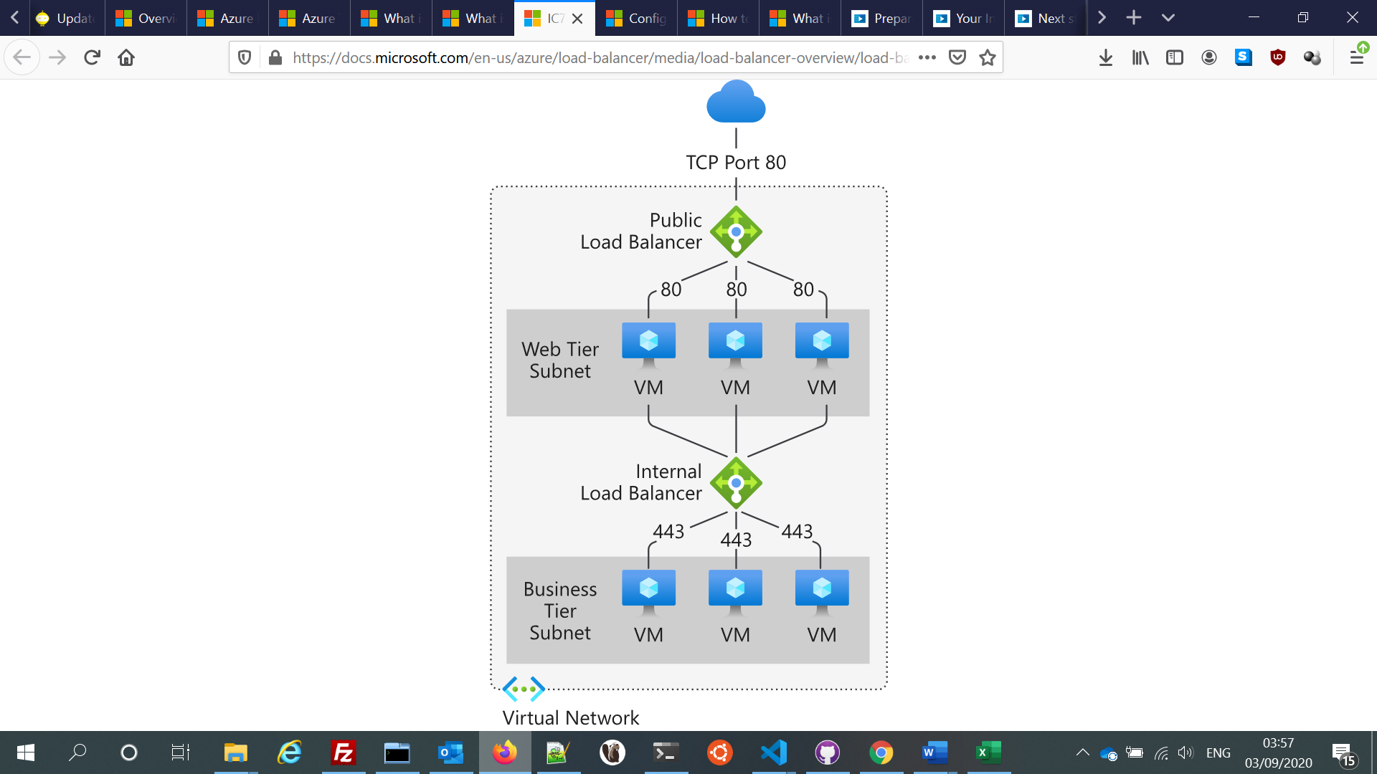

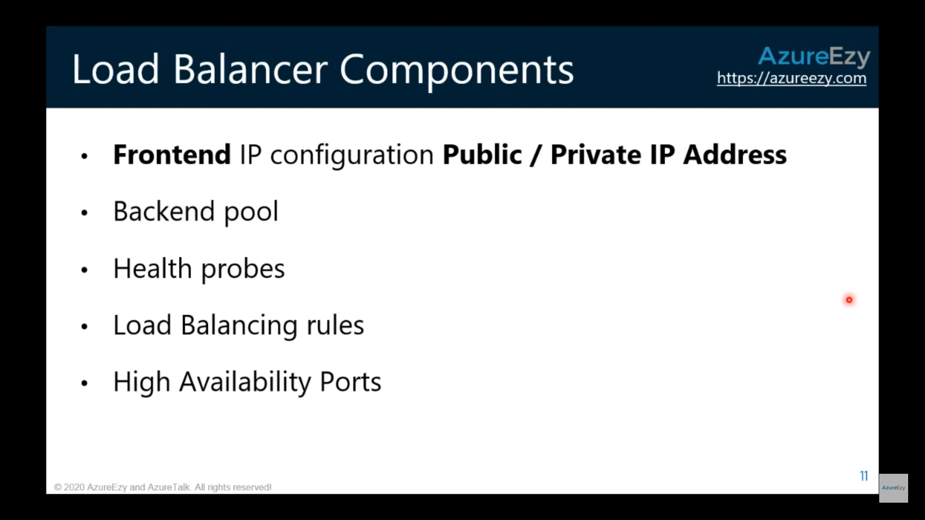

### Backend Pools

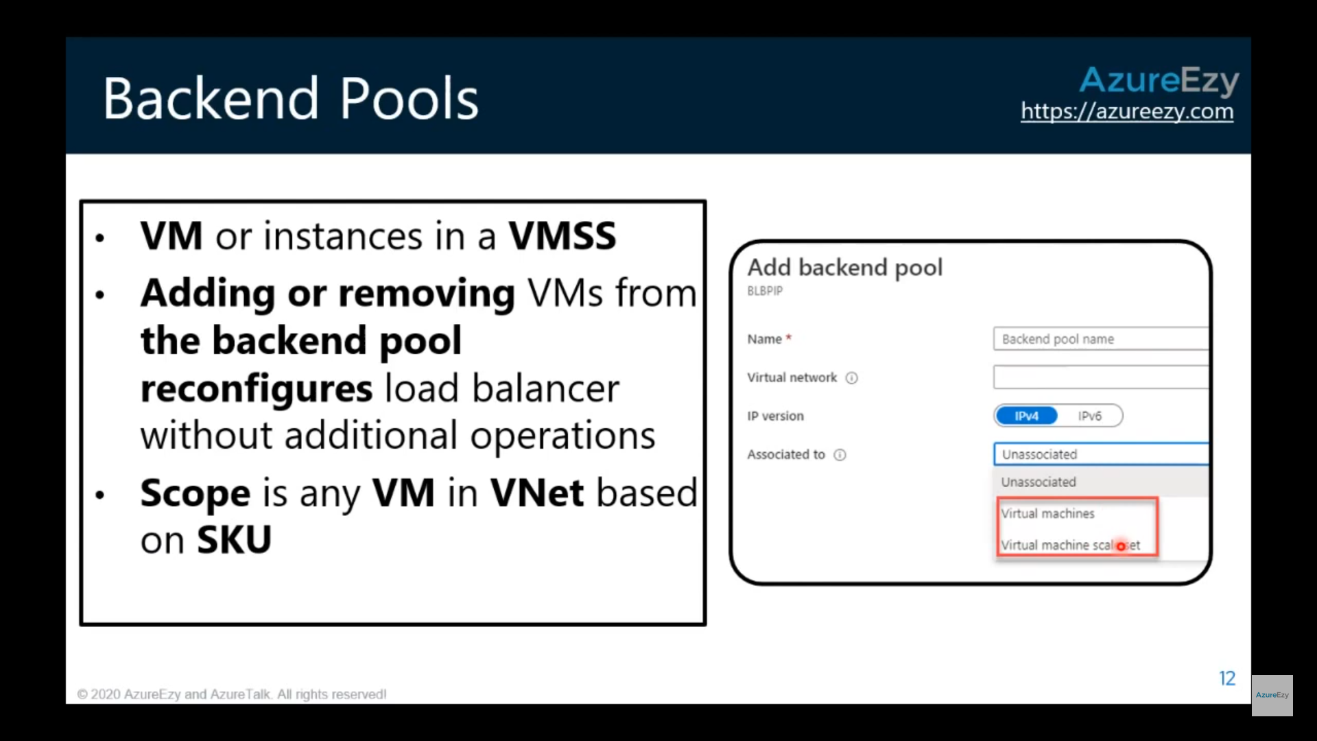

### Health Probe

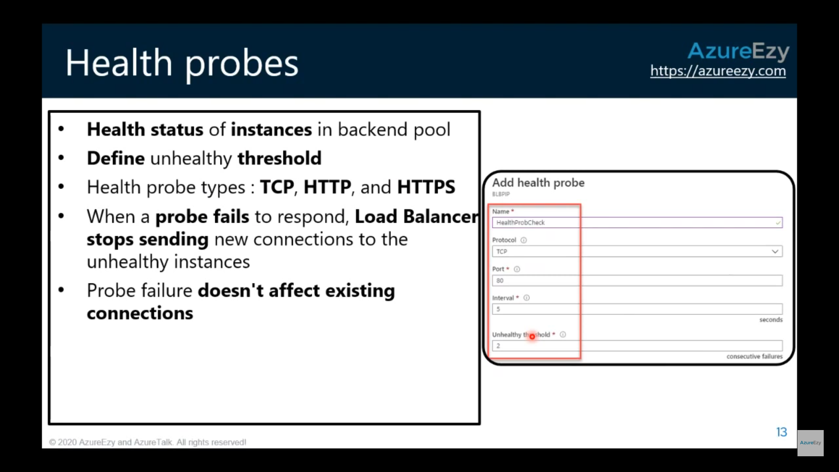

### Session Persistence

* 1. None

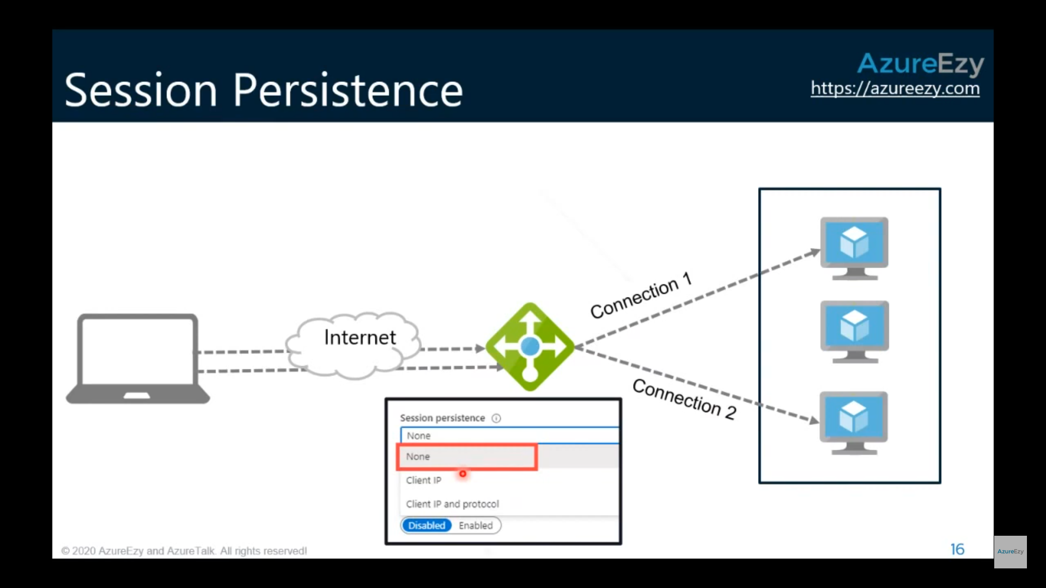

* 1. Client IP

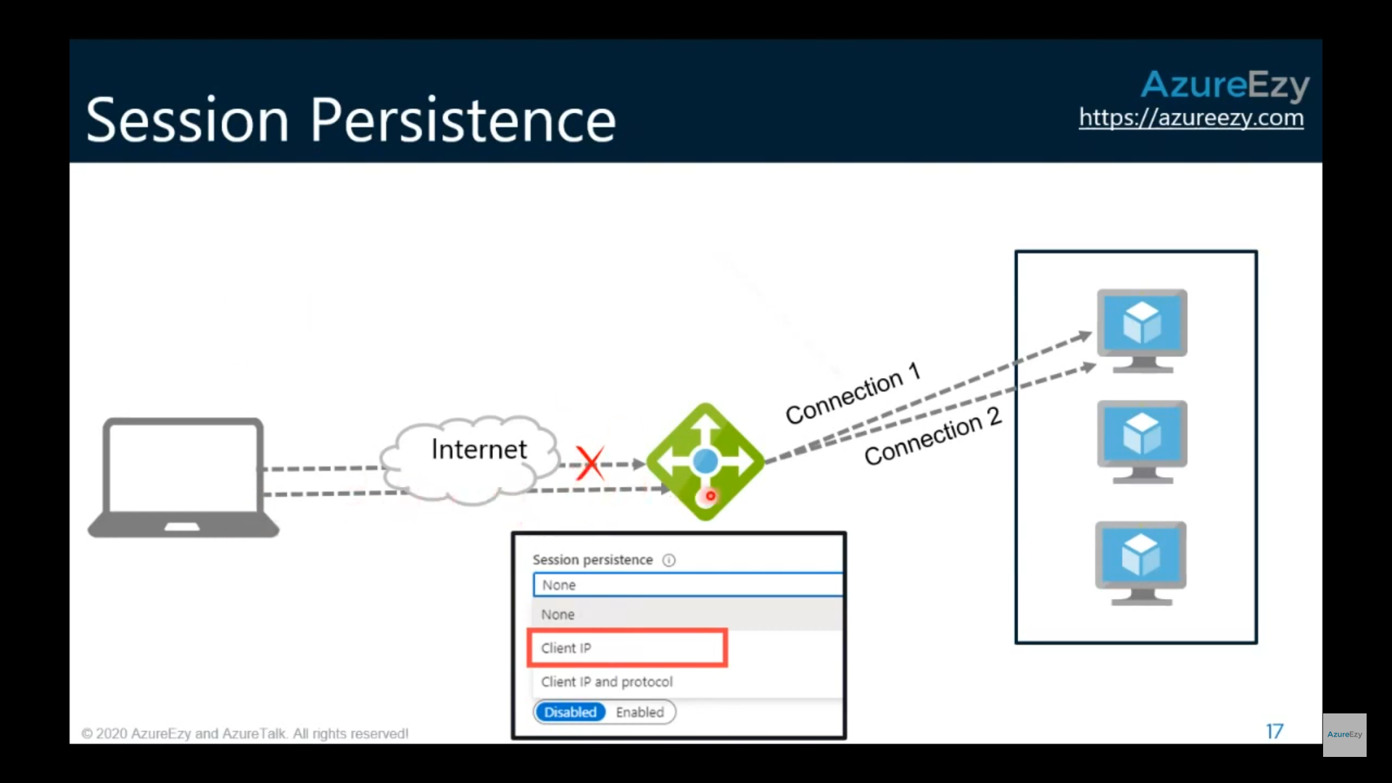

* 1. Client IP and protocol

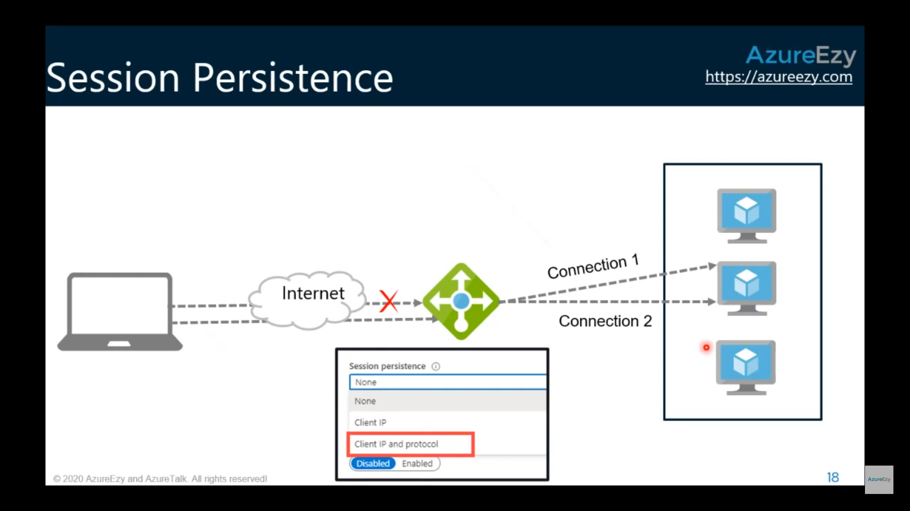

### Load Balancer SKUs

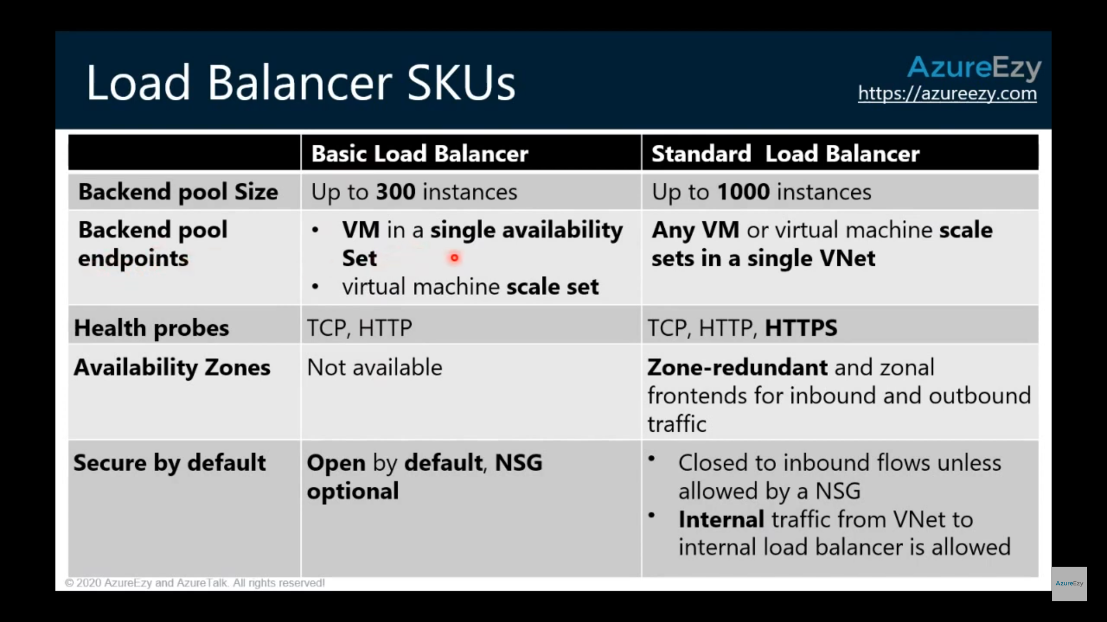

<https://azure.microsoft.com/en-us/support/legal/sla/load-balancer/v1_0/>

We guarantee that a Load Balanced Endpoint using **Azure Standard Load Balancer**, serving two or more Healthy Virtual Machine Instances, will be **available 99.99% of the time**.

**Basic Load Balancer is excluded from this SLA.**

## Azure Load Balancer vs Azure Application Gateway vs Azure Traffic Monitor

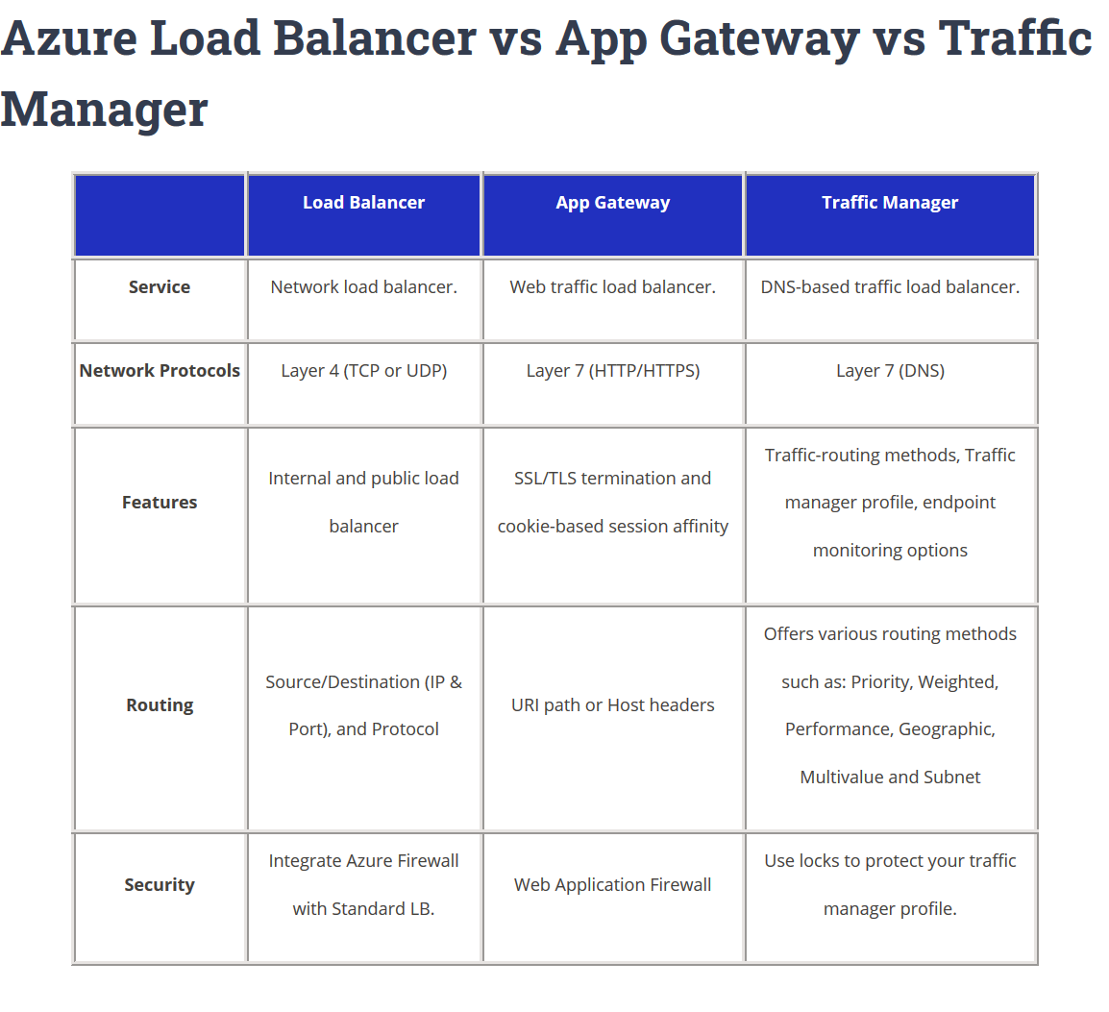

<https://tutorialsdojo.com/azure-load-balancer-vs-app-gateway-vs-traffic-manager/>

## Azure Application Gateway

<https://docs.microsoft.com/en-us/azure/application-gateway/overview>

<https://www.youtube.com/watch?v=bPyH0W5oDT8>

[Application Gateway](https://docs.microsoft.com/en-us/azure/application-gateway/overview) provides application delivery controller (ADC) as a service, offering various Layer 7 load-balancing capabilities. Use it to optimize web farm productivity by offloading CPU-intensive SSL termination to the gateway.

Application Gateway can make routing decisions based on additional attributes of an HTTP request, for example URI path or host headers. For example, you can route traffic based on the incoming URL. So if /images is in the incoming URL, you can route traffic to a specific set of servers (known as a pool) configured for images. If /video is in the URL, that traffic is routed to another pool that's optimized for videos.

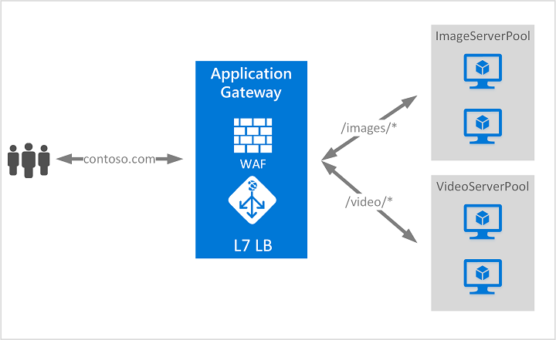

### Application Gateway Features

<https://docs.microsoft.com/en-us/azure/application-gateway/features>

* [Secure Sockets Layer (SSL/TLS) termination](https://docs.microsoft.com/en-us/azure/application-gateway/features#secure-sockets-layer-ssltls-termination)
* [Autoscaling](https://docs.microsoft.com/en-us/azure/application-gateway/features#autoscaling)
* [Zone redundancy](https://docs.microsoft.com/en-us/azure/application-gateway/features#zone-redundancy)
* [Static VIP](https://docs.microsoft.com/en-us/azure/application-gateway/features#static-vip)
* [Web Application Firewall](https://docs.microsoft.com/en-us/azure/application-gateway/features#web-application-firewall)
* [Ingress Controller for AKS](https://docs.microsoft.com/en-us/azure/application-gateway/features#ingress-controller-for-aks)
* [URL-based routing](https://docs.microsoft.com/en-us/azure/application-gateway/features#url-based-routing)
* [Multiple-site hosting](https://docs.microsoft.com/en-us/azure/application-gateway/features#multiple-site-hosting)
* [Redirection](https://docs.microsoft.com/en-us/azure/application-gateway/features#redirection)
* [Session affinity](https://docs.microsoft.com/en-us/azure/application-gateway/features#session-affinity)
* [Websocket and HTTP/2 traffic](https://docs.microsoft.com/en-us/azure/application-gateway/features#websocket-and-http2-traffic)
* [Connection draining](https://docs.microsoft.com/en-us/azure/application-gateway/features#connection-draining)
* [Custom error pages](https://docs.microsoft.com/en-us/azure/application-gateway/features#custom-error-pages)
* [Rewrite HTTP headers and URL](https://docs.microsoft.com/en-us/azure/application-gateway/features#rewrite-http-headers-and-url)
* [Sizing](https://docs.microsoft.com/en-us/azure/application-gateway/features#sizing)

### Application Gateway Infrastructure

<https://docs.microsoft.com/en-us/azure/application-gateway/configuration-overview>

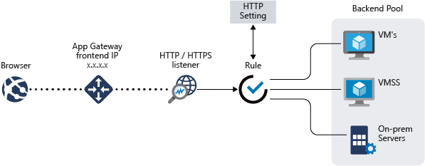

The Application Gateway infrastructure includes

* **virtual network**
* **subnets:** A **dedicated subnet** is required for Application Gateway
* **network security groups**
* **user defined routes**

#### Front-end IP address

You can configure the application gateway to have a public IP address, a private IP address, or both.

#### Listeners

A listener is a logical entity that checks for incoming connection requests by using the port, protocol, host, and IP address.

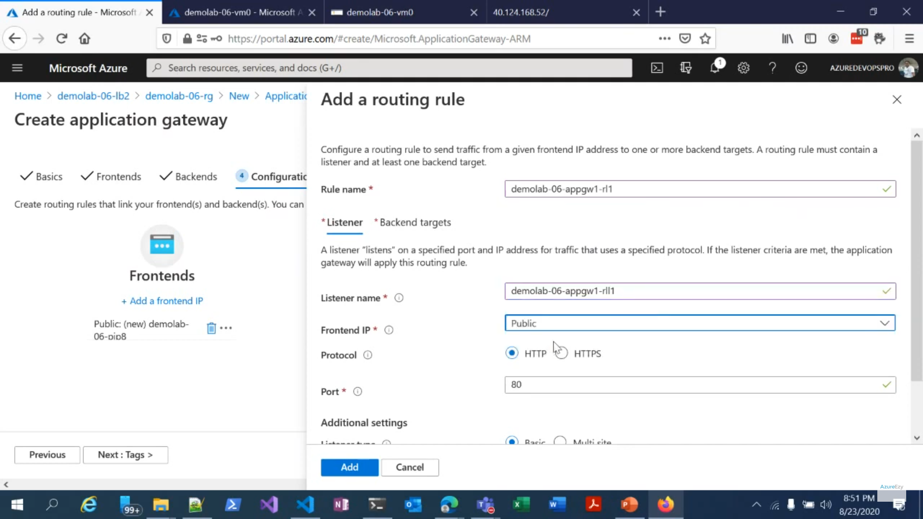

#### Request routing rules

When you create an application gateway by using the Azure portal, you create a default rule

### Routing / listeners

#### URL Path based routing

<https://docs.microsoft.com/en-us/azure/application-gateway/url-route-overview>

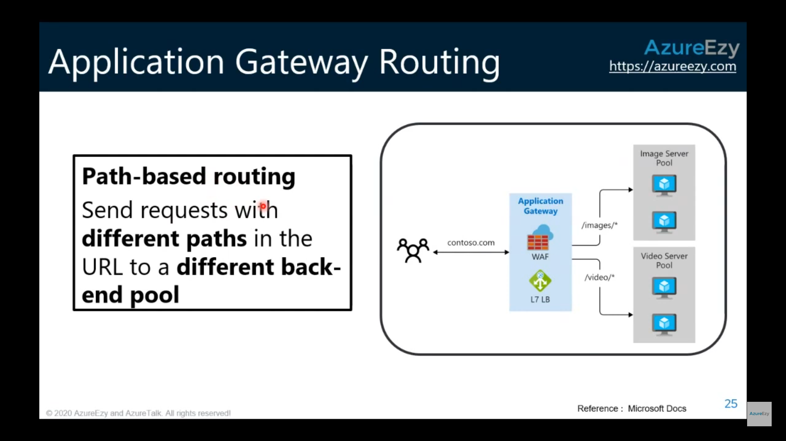

#### Multiple site hosting

<https://docs.microsoft.com/en-us/azure/application-gateway/multiple-site-overview>

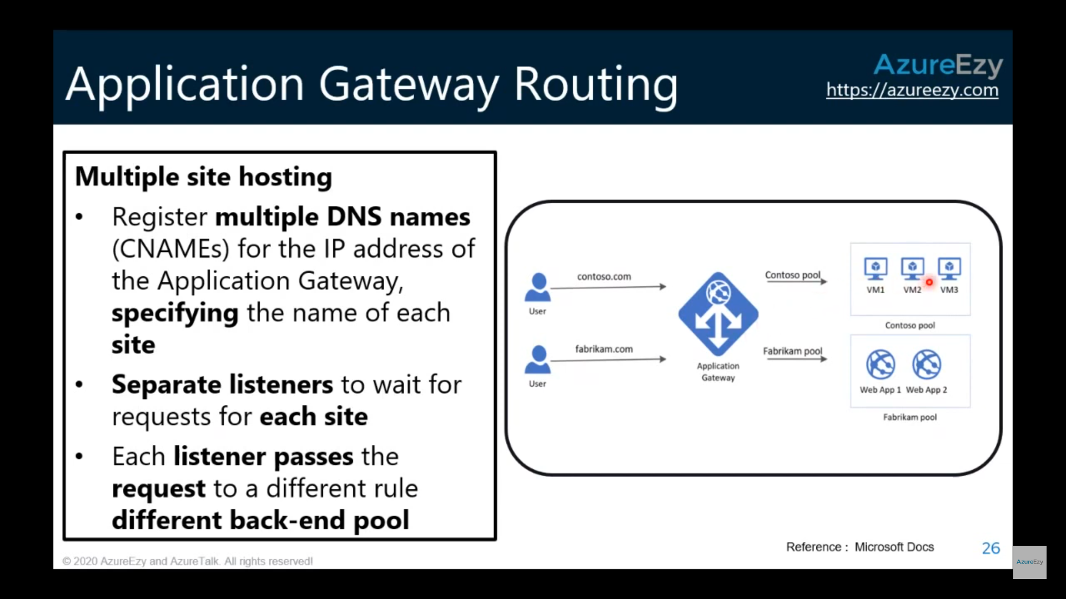

#### Redirection

<https://docs.microsoft.com/en-us/azure/application-gateway/redirect-overview>

Application Gateway redirection support offers the following capabilities:

* **Global redirection**

Redirects from one listener to another listener on the gateway. This enables HTTP to HTTPS redirection on a site.

* **Path-based redirection**

This type of redirection enables HTTP to HTTPS redirection only on a specific site area, for example a shopping cart area denoted by /cart/\*.

* **Redirect to external site**

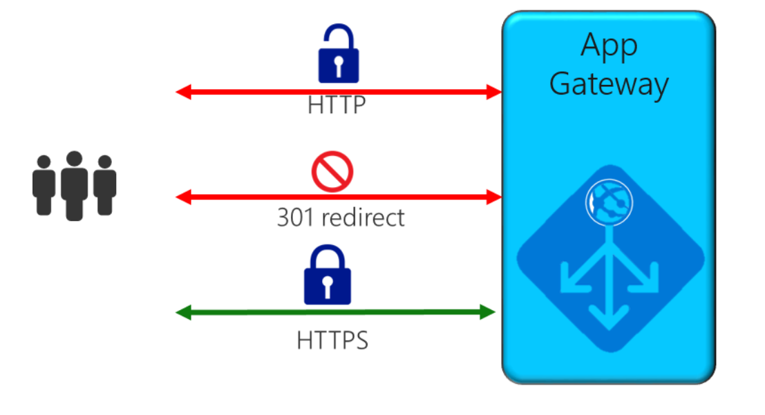

#### Rewrite HTTP headers and URL

https://docs.microsoft.com/en-us/azure/application-gateway/rewrite-http-headers-url

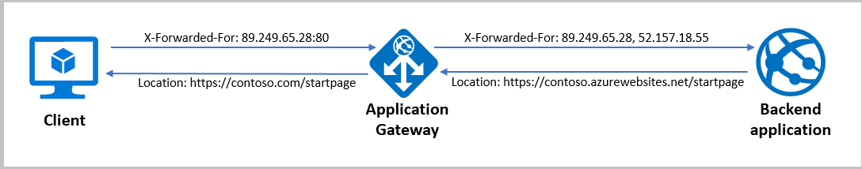

### Web Application Firewall (WAF)

<https://docs.microsoft.com/en-us/azure/web-application-firewall/ag/ag-overview>

The Web Application Firewall (WAF) is a feature of **Application Gateway** that provides centralized inbound protection of your web applications from common exploits and vulnerabilities.

**Features**

* SQL-injection protection.
* Cross-site scripting protection.
* Protection against other common web attacks, such as command injection, HTTP request smuggling, HTTP response splitting, and remote file inclusion.
* Protection against HTTP protocol violations.

Web Application Firewall does not support RDP/SSH.

### SLA

<https://azure.microsoft.com/en-us/support/legal/sla/application-gateway/v1_1/>

We guarantee that each **Application Gateway Cloud Service** having two or more medium or larger instances will be available at least 99.95% of the time.

## Traffic Manager

<https://docs.microsoft.com/en-us/azure/traffic-manager/traffic-manager-overview>

[Traffic Manager](https://docs.microsoft.com/en-us/azure/traffic-manager/traffic-manager-overview) is a DNS-based traffic load balancer that enables you to **distribute traffic optimally to services across global Azure regions**, while providing high availability and responsiveness. Because Traffic Manager is a **DNS-based(Level 3-4 and higher as well as it communicates directly )** load-balancing service, it load balances only at the domain level. For that reason, it can't fail over as quickly as Front Door, because of common challenges around DNS caching and systems not honoring DNS TTLs.

<https://docs.microsoft.com/en-us/azure/traffic-manager/traffic-manager-how-it-works>

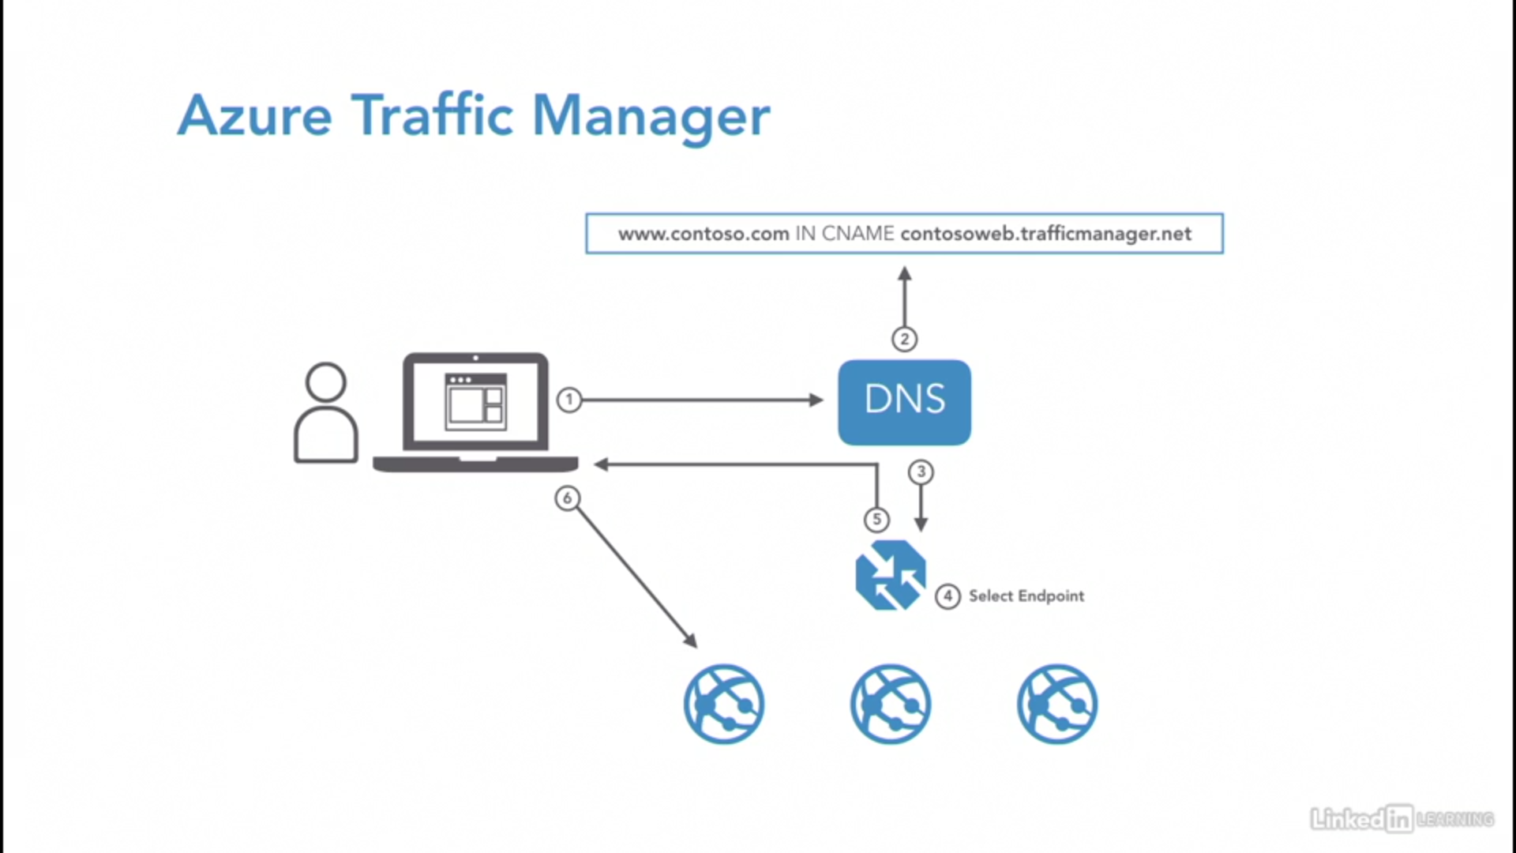

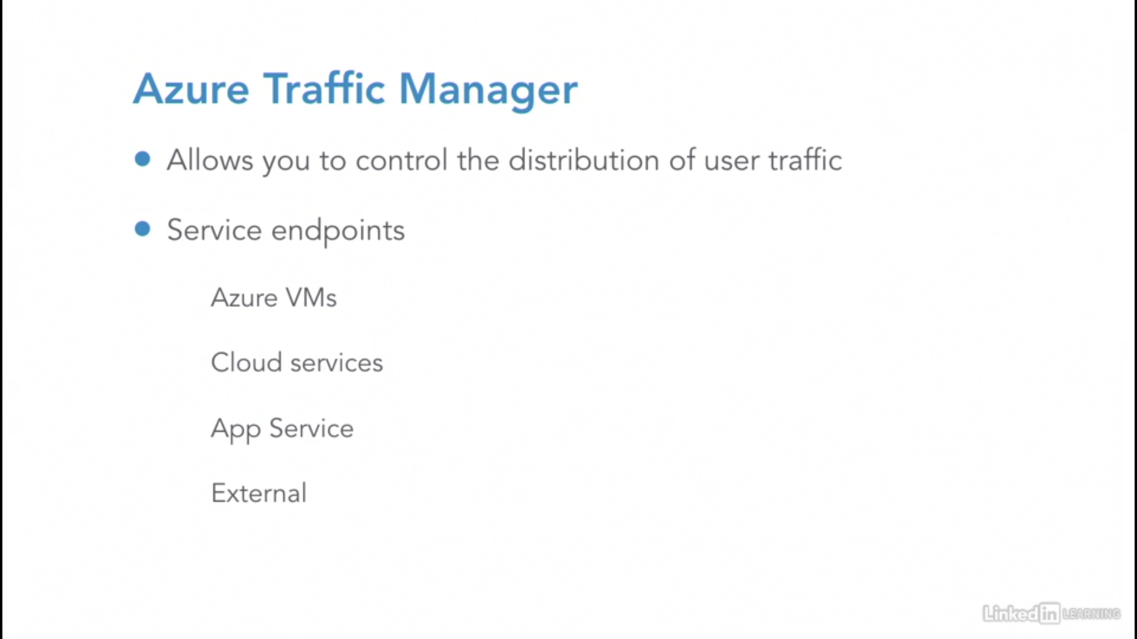

### Routing methods

<https://docs.microsoft.com/en-us/azure/traffic-manager/traffic-manager-routing-methods>

* [**Priority**](https://docs.microsoft.com/en-us/azure/traffic-manager/traffic-manager-routing-methods#priority-traffic-routing-method)**:** Select **Priority** when you want to use a primary service endpoint for all traffic, and provide backups in case the primary or the backup endpoints are unavailable.

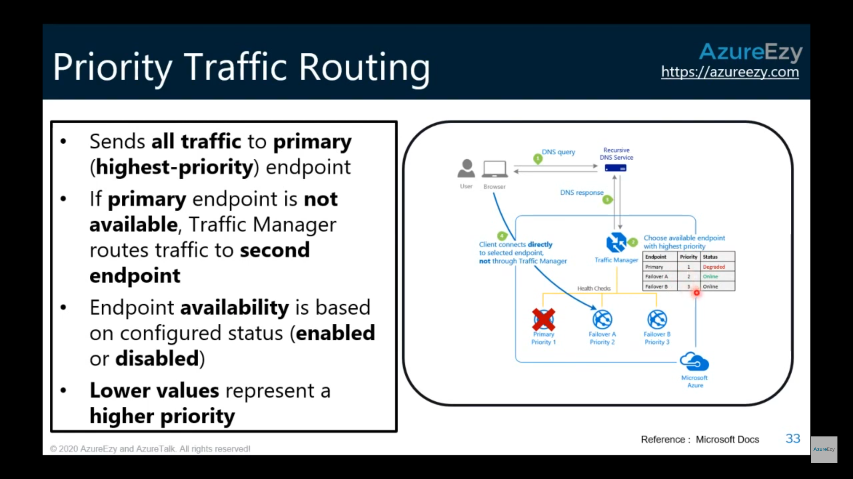

* [**Weighted**](https://docs.microsoft.com/en-us/azure/traffic-manager/traffic-manager-routing-methods#weighted)**:** Select **Weighted** when you want to distribute traffic across a set of endpoints, either evenly or according to weights, which you define.

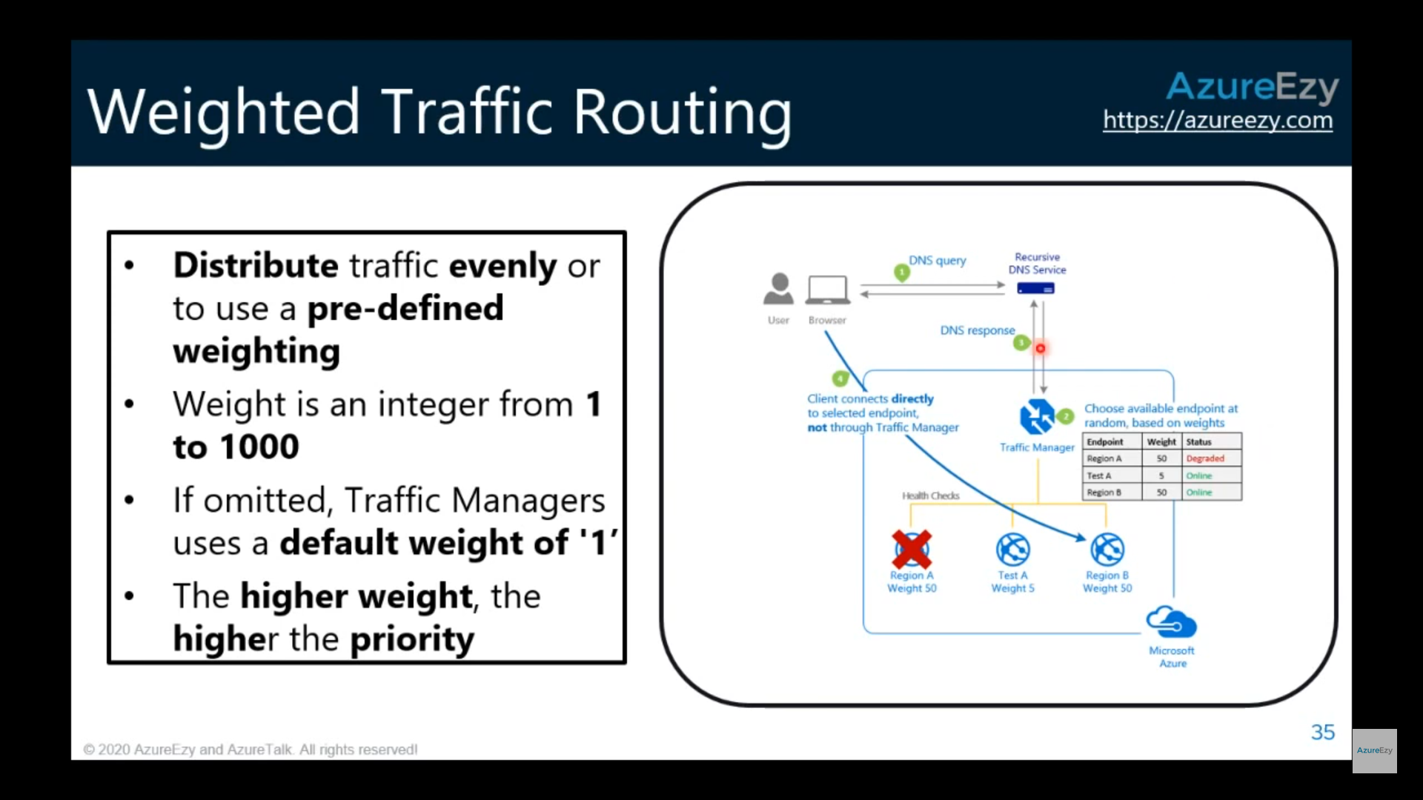

* [**Performance**](https://docs.microsoft.com/en-us/azure/traffic-manager/traffic-manager-routing-methods#performance)**:** Select **Performance** when you have endpoints in different geographic locations and you want end users to use the "closest" endpoint in terms of the lowest network latency.

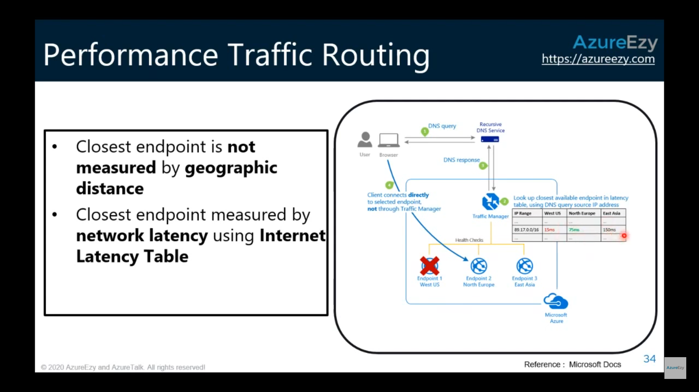

* [**Geographic**](https://docs.microsoft.com/en-us/azure/traffic-manager/traffic-manager-routing-methods#geographic)**:** Select **Geographic** so that users are directed to specific endpoints (Azure, External, or Nested) based on which geographic location their DNS query originates from. This empowers Traffic Manager customers to enable scenarios where knowing a user’s geographic region and routing them based on that is important. Examples include complying with data sovereignty mandates, localization of content & user experience and measuring traffic from different regions.

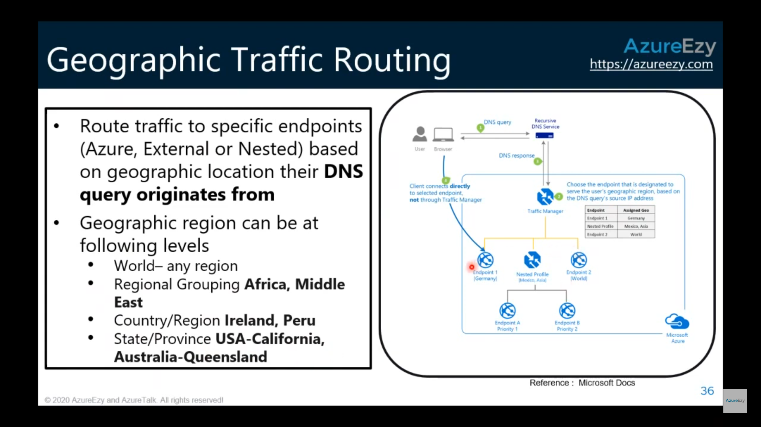

* [**Multivalue**](https://docs.microsoft.com/en-us/azure/traffic-manager/traffic-manager-routing-methods#multivalue)**:** Select **MultiValue** for Traffic Manager profiles that can only have IPv4/IPv6 addresses as endpoints. When a query is received for this profile, all healthy endpoints are returned.
* [**Subnet**](https://docs.microsoft.com/en-us/azure/traffic-manager/traffic-manager-routing-methods#subnet)**:** Select **Subnet** traffic-routing method to map sets of end-user IP address ranges to a specific endpoint within a Traffic Manager profile. When a request is received, the endpoint returned will be the one mapped for that request’s source IP address.

FAQs Traffic Manager:

<https://docs.microsoft.com/en-us/azure/traffic-manager/traffic-manager-faqs>

1. What types of traffic can be routed using Traffic Manager?

Traffic Manager can route traffic that originates from the public internet to a set of endpoints that are also internet facing. If you have endpoints that are inside a private network (for example, an internal version of [Azure Load Balancer](https://docs.microsoft.com/en-us/azure/load-balancer/components#frontend-ip-configurations)) or have users making DNS requests from such internal networks, then you cannot use Traffic Manager to route this traffic.

1. What application protocols can I use with Traffic Manager?

Traffic Manager works at the DNS level. Once the DNS lookup is complete, clients connect to the application endpoint directly, not through Traffic Manager. Therefore, the connection can use any application protocol.

## Azure Front Door

<https://docs.microsoft.com/en-us/azure/frontdoor/front-door-overview>

[Front Door](https://docs.microsoft.com/en-us/azure/frontdoor/front-door-overview) is an application delivery network that provides **global load balancing** and site acceleration service for web applications. It offers Layer 7 capabilities for your application like SSL offload, path-based routing, fast failover, caching, etc. to improve performance and high-availability of your applications.

### URL-based routing

For example, requests for http://www.contoso.com/users/\* are routed to UserProfilePool, and http://www.contoso.com/products/\* are routed to ProductInventoryPool.

### Multiple-site hosting

For example, Front Door can serve traffic for images.contoso.com and videos.contoso.com from two backend pools called ImagePool and VideoPool.

Similarly, you can have two different domains www.contoso.com and www.fabrikam.com configured on the same Front Door.

### TLS termination

Front Door supports **TLS** termination at the edge that is, individual users can set up a TLS connection with Front Door environments instead of establishing it over long haul connections with the application backend.

### Application layer security

Azure Front Door allows you to author custom Web Application Firewall (WAF) rules for access control to protect your HTTP/HTTPS workload from exploitation based on client IP addresses, country code, and http parameters.

FAQ Front Door

<https://docs.microsoft.com/en-us/azure/frontdoor/front-door-faq>

1. What is the difference between Azure Front Door and Azure Application Gateway?

While both Front Door and Application Gateway are layer 7 (HTTP/HTTPS) load balancers, the primary difference is that Front Door is a global service whereas Application Gateway is a regional service. While Front Door can load balance between your different scale units/clusters/stamp units across regions, Application Gateway allows you to load balance between your VMs/containers etc. that is within the scale unit.

1. When should we deploy an Application Gateway behind Front Door?

The key scenarios why one should use Application Gateway behind Front Door are:

Front Door can perform path-based load balancing only at the global level but if one wants to load balance traffic even further within their virtual network (VNET) then they should use Application Gateway.

Since Front Door doesn't work at a VM/container level, so it cannot do Connection Draining. However, Application Gateway allows you to do Connection Draining.

With an Application Gateway behind Front Door, one can achieve 100% TLS/SSL offload and route only HTTP requests within their virtual network (VNET).

Front Door and Application Gateway both support session affinity. While Front Door can direct subsequent traffic from a user session to the same cluster or backend in a given region, Application Gateway can direct affinitize the traffic to the same server within the cluster.

1. Can we deploy Azure Load Balancer behind Front Door?

Yes